

THE 14th SUNDAY

AFTER TRINITY



A SERVICE OF

HOLY COMMUNION

September 21, 2025

**GRACE NOTES – September 21, 2025**

**FALL SERMON SERIES.** We will be looking at the “I Am” statements of Jesus from the Gospel of John until All Saints Sunday.

**HOST A STUDENT SUNDAY** is next Sunday, September 28. Residents, please sign up to host students for a meal – brunch, lunch, or dinner! Students, please sign up to get connected with residents. Please see the back of the bulletin to sign up. Email Dr. Shepson with any questions at dshepson@graceanglicanonline.com.

**CHILDREN’S LITURGY** is a time when kids (ages 3-6) meet during the 5PM worship hour (it’s noted in the bulletin where in the service they are accompanied downstairs). During Children’s Liturgy the kids worship, pray, learn a lesson from the Bible, and do a craft. They return to the service at The Peace.

**CHRISTIAN EDUCATION.** Starting today, our very own Dr. Alden McCray, will teach a four-week series on one of the most central claims of Scripture: the identity of God. We'll be thinking about some key aspects of God's nature and what these mean for how we think about God's work and the shape of our faith. Please join us at 4PM!

**SABBATICAL.** Pastor Ethan was granted a sabbatical from mid-summer to mid-fall. Please pray for a season of refreshment for the entire Magness family.

**WOMEN’S HIKE.** The third annual women's hike will take place on Saturday, October 4.We'll meet at the Jennings Blazing Star Trail parking lot at **9AM.** Afterwards, we'll head to Rooster’s Coffee Bar in Slippery Rock (ETA 10:45AM) to enjoy coffee and fellowship until around noon. Questions? Email: [mcowan@graceanglicanonline.com](mailto:mcowan@graceanglicanonline.com)

**MISSION SPOTLIGHT.** This month we pray for Andrew and Amy, along with their children, who are currently serving in North Africa. We ask God to bless them in their challenging context with provision, protection and a profoundly fruitful ministry.

**BRASS PLAYERS.** We are looking for brass players for the morning and/or evening services on All Saints Sunday on Nov 2. If you are interested in playing, please reach out to Andrew Mitchell at [mitchellaj@gcc.edu](mailto:mitchellaj@gcc.edu).

**INFANT CARE ROOM.** The library is available as a dedicated space to care for your infants during the service. The livestream will also be available in this space during evening worship services.

**NURSERY.** We offer nursery for children (infants to three-year-olds) downstairs.

**THE CASA YOUTH MINISTRY** is on Tuesday nights at 7pm at Holy Trinity.

**PASTORAL CARE.** Please reach out to Pastor David for any pastoral care needs at [dbeck@graceanglicanonline.com](mailto:dbeck@graceanglicanonline.com) or 810-772-8291.

**WAYS TO GIVE AT GRACE**

-Offering plate

-Mail: PO Box 45 Grove City PA 16127

-Venmo: GraceAnglicanChurch

-PayPal: [donate@graceanglicanonline.com](mailto:donate@graceanglicanonline.com)

**Opening Hymn:** Come Thou Fount Words: Robert Robinson

1. Come Thou Fount of every blessing, tune my heart to sing Thy grace;  
Streams of mercy, never ceasing, call for songs of loudest praise.  
Teach me some melodious sonnet, sung by flaming tongues above.  
Praise the mount! I'm fixed upon it, mount of Thy redeeming love.

2. Here I raise mine Ebenezer; hither by Thy help I'm come;  
And I hope, by Thy good pleasure, safely to arrive at home.  
Jesus sought me when a stranger, wandering from the fold of God;  
He, to rescue me from danger, bought me with His precious blood.

3. O to grace how great a debtor, daily I'm constrained to be!  
Let Thy goodness, as a fetter, bind my wandering heart to Thee.  
Prone to wander, Lord, I feel it, prone to leave the God I love;  
Here's my heart, O take and seal it, seal it for Thy courts above.

**Minister***.*  Blessed be God: the Father, the Son, & the Holy Spirit.

**Answer***.* And blessed be his Kingdom, now and forever. Amen.

**Minister**. Let us pray [together saying,]

**The Collect for Purity***,*said by all

A

LMIGHTY God, to you all hearts are open, all desires known, and from you no secrets are hid: Cleanse the thoughts of our hearts by the inspiration of your Holy Spirit, that we may perfectly love you, and worthily magnify your holy Name; through Christ our Lord. Amen.

H

**The Summary of the Law**

EAR what our Lord Jesus Christ says. You shall love the Lord your God with all your heart, and with all your soul, and with all your mind. This is the first and great commandment. And the second is like it; You shall love your neighbor as your self. On these two commandments depend all the Law and the Prophets. -MATTHEW 22:37-40.

Lord, have mercy upon us. **Christ, have mercy upon us**. Lord, have mercy upon us.

A

LMIGHTY Lord and everlasting God, we beseech you to direct, sanctify, and govern, both our hearts and bodies, in the ways of your laws, and in the works of your commandments; that, through your most mighty protection, both here and always, we may be preserved in body and soul; through our Lord and Savior Jesus Christ. **Amen**.

**Minister***.* The Lord be with you.

**Answer***.* And with your spirit.

**Minister***.* Let us pray.

**Collect for the Fourteenth Sunday after Trinity**

O Lord, you have taught us that without love, all our deeds are worth nothing: Send your Holy Spirit and pour into our hearts that most excellent gift of charity, the true bond of peace and of all virtues, without which whoever lives is counted dead before you; grant this for the sake of your Son Jesus Christ, who lives and reigns with you and the Holy Spirit, one God, for ever and ever. **Amen.**

**The Old Testament Lesson:** Exodus 3:1-15 (ESV)

**Reader**. A reading from the Book of Exodus.

1 Now Moses was keeping the flock of his father-in-law, Jethro, the priest of Midian, and he led his flock to the west side of the wilderness and came to Horeb, the mountain of God. **2**And the angel of the Lord appeared to him in a flame of fire out of the midst of a bush. He looked, and behold, the bush was burning, yet it was not consumed. **3**And Moses said, “I will turn aside to see this great sight, why the bush is not burned.” **4**When the Lord saw that he turned aside to see, God called to him out of the bush, “Moses, Moses!” And he said, “Here I am.” **5**Then he said, “Do not come near; take your sandals off your feet, for the place on which you are standing is holy ground.” **6**And he said, “I am the God of your father, the God of Abraham, the God of Isaac, and the God of Jacob.” And Moses hid his face, for he was afraid to look at God. **7**Then the Lord said, “I have surely seen the affliction of my people who are in Egypt and have heard their cry because of their taskmasters. I know their sufferings, **8**and I have come down to deliver them out of the hand of the Egyptians and to bring them up out of that land to a good and broad land, a land flowing with milk and honey, to the place of the Canaanites, the Hittites, the Amorites, the Perizzites, the Hivites, and the Jebusites. **9**And now, behold, the cry of the people of Israel has come to me, and I have also seen the oppression with which the Egyptians oppress them. **10**Come, I will send you to Pharaoh that you may bring my people, the children of Israel, out of Egypt.” **11**But Moses said to God, “Who am I that I should go to Pharaoh and bring the children of Israel out of Egypt?” **12**He said, “But I will be with you, and this shall be the sign for you, that I have sent you: when you have brought the people out of Egypt, you shall serve God on this mountain.” **13**Then Moses said to God, “If I come to the people of Israel and say to them, ‘The God of your fathers has sent me to you,’ and they ask me, ‘What is his name?’ what shall I say to them?” **14**God said to Moses, “I am who I am.” And he said, “Say this to the people of Israel: ‘I am has sent me to you.’” **15**God also said to Moses, “Say this to the people of Israel: ‘The Lord, the God of your fathers, the God of Abraham, the God of Isaac, and the God of Jacob, has sent me to you.’ This is my name forever, and thus I am to be remembered throughout all generations.

**Reader**. The Word of the Lord. **Answer**. Thanks be to God.

***\*EVENING: Kids (ages 3-6) may be taken to Children’s Liturgy & retrieved at The Peace.***

**Psalm 138:1-4**

1 I will give thanks to you, O Lord, with my whole heart; *

even before the gods will I sing praises to you.

2 I will worship toward your holy temple and praise your Name, because of

your loving-kindness and truth, *

for you have magnified your Name and your word above all things.

3 When I called upon you, you heard me *

and gave me increase of strength.

4 All the kings of the earth shall praise you, O Lord, *

for they have heard the words of your mouth.

**The Gospel Lesson**: John 8:48-59 (ESV)

**Reader**. The Holy Gospel of our Lord Jesus Christ according to John.

**Answer**. Glory to you, Lord Christ.

**48**The Jews answered him, “Are we not right in saying that you are a Samaritan and have a demon?” **49**Jesus answered, “I do not have a demon, but I honor my Father, and you dishonor me. **50**Yet I do not seek my own glory; there is One who seeks it, and he is the judge. **51**Truly, truly, I say to you, if anyone keeps my word, he will never see death.” **52**The Jews said to him, “Now we know that you have a demon! Abraham died, as did the prophets, yet you say, ‘If anyone keeps my word, he will never taste death.’ **53**Are you greater than our father Abraham, who died? And the prophets died! Who do you make yourself out to be?” **54**Jesus answered, “If I glorify myself, my glory is nothing. It is my Father who glorifies me, of whom you say, ‘He is our God.’ **55**But you have not known him. I know him. If I were to say that I do not know him, I would be a liar like you, but I do know him and I keep his word. **56**Your father Abraham rejoiced that he would see my day. He saw it and was glad.” **57**So the Jews said to him, “You are not yet fifty years old, and have you seen Abraham?” **58**Jesus said to them, “Truly, truly, I say to you, before Abraham was, I am.” **59**So they picked up stones to throw at him, but Jesus hid himself and went out of the temple.

**Reader**. The Gospel of the Lord. **Answer**. Praise to you, Lord Christ.

**The Sermon** The Rev’d Chad Lawrence

**The Nicene Creed**

LET us confess our faith in the words of the Nicene Creed:

W

E believe in one God, the Father, the Almighty, maker of heaven and earth, of all that is, visible and invisible.

WE believe in one Lord, Jesus Christ, the only-begotten Son of God, eternally begotten of the Father, God from God, Light from Light, true God from true God, begotten, not made, of one Being with the Father; through him all things were made. For us and for our salvation he came down from heaven, was incarnate from the Holy Spirit and the Virgin Mary, and was made man. For our sake he was crucified under Pontius Pilate; he suffered death and was buried. On the third day he rose again in accordance with the Scriptures; he ascended into heaven and is seated at the right hand of the Father. He will come again in glory to judge the living and the dead, and his kingdom will have no end.

WE believe in the Holy Spirit, the Lord, the giver of life, who proceeds from the Father and the Son, who with the Father and the Son is worshiped and glorified, who has spoken through the prophets. We believe in one holy catholic and apostolic Church. We acknowledge one Baptism for the forgiveness of sins. We look for the resurrection of the dead, and the life of the world to come. Amen.

**The Prayers**

Father, we pray for your holy catholic Church;

**That we all may be one in Christ.**

Grant that every member of the Church may truly and humbly serve you;

**That your Name may be glorified by all people.**

We pray for all bishops, priests, and deacons;

**That they may be faithful ministers of your Word and Sacraments.**

We pray for all who govern and hold authority in the nations of the world;

**That there may be justice and peace on the earth.**

We pray for Andrew, Amy and their children, asking you to bless their work in North Africa. Give us grace to do your will in all that we undertake; **That our works may find favor in your sight.**

Have compassion on those who suffer from any grief or trouble;

**That they may be delivered from their distress.**

We praise you for your saints who have entered into joy;

**May we also come to share in your heavenly kingdom.**

Let us pray for our own needs and those of others. (The People may add their own petitions.)

Let us commend ourselves, and one another, and all our life to Christ our God. **For yours is the majesty, O Father, Son, and Holy Spirit;  yours is the kingdom and the power and the glory, now and forever.  Amen.**

A

**Invitation to Confession**

LL who truly and earnestly repent of your sins, and seek to live in love and charity with your neighbors, and intend to lead the new life, following the commandments of God, and walking in his holy ways: draw near with faith and make your humble confession to Almighty God.

A

**General Confession***,*said by all.

LMIGHTY God, Father of our Lord Jesus Christ, maker and judge of us all: We acknowledge and lament our many sins and offenses, which we have committed by thought, word, and deed against your divine majesty, provoking most justly your righteous anger against us. We are deeply sorry for these our transgressions; the burden of them is more than we can bear. Have mercy upon us, Have mercy upon us, most merciful Father; for your Son our Lord Jesus Christ’s sake, forgive us all that is past; and grant that we may evermore serve and please you in newness of life, to the honor and glory of your Name; through Jesus Christ our Lord. Amen.

A

**Absolution**

LMIGHTY God, our heavenly Father, who in his great mercy has promised forgiveness of sins to all those who sincerely repent and with true faith turn to him, have mercy upon you, pardon and deliver you from all your sins, confirm and strengthen you in all goodness, and bring you to everlasting life; through Jesus Christ our Lord.  **Amen.**

H

**The Comfortable Words**

EAR the comfortable words from the Word of God to all who truly turn to him.

Come to me, all who labor and are heavy laden, and I will give you rest.

-MATTHEW 11:28

God so loved the world, that he gave his only-begotten Son, that whoever believes in him should not perish but have eternal life. -JOHN 3:16

The saying is trustworthy and deserving of full acceptance, that Christ Jesus came into the world to save sinners. -1 TIMOTHY 1:15

If anyone sins, we have an advocate with the Father, Jesus Christ the righteous. He is the propitiation for our sins, and not for ours only, but also for the sins of the whole world. -1 JOHN 2:1-2

**Minister.** The peace of the Lord be always with you.

**People.** And with your spirit.

**Offering and Doxology** (tune: lasst uns erfreuen)

**The Sacrament of Holy Communion** (the 1662 Order)

**Minister**. The Lord be with you.

**Answer**. And with your spirit.

**Minister**. Lift up your hearts.

**Answer**. We lift them up to the Lord.

**Minister**. Let us give thanks to the Lord our God.

**Answer**. It is right to give Him thanks and praise.

I

T is right, our duty and our joy, always and everywhere to give thanks to you, Father Almighty, Creator of heaven and earth; Through Jesus Christ our Lord, who on the first day of the week overcame death and the grave, and by his glorious resurrection opened to us the way of everlasting life.

T

HEREFORE we praise you, joining our voices with Angels and Archangels and with all the company of heaven, who for ever sing this hymn to proclaim the glory of your Name: **Holy, holy, holy Lord God of power and might. Heaven and earth are full of your glory. Hosanna in the highest. Blessed is he who comes in the Name of the Lord. Hosanna in the highest.**

W

**The Prayer of Humble Access,** said by all, kneeling.

E do not presume to come to this your table, O merciful Lord, trusting in our own righteousness, but in your abundant and great mercies. We are not worthy so much as to gather up the crumbs under your table; but you are the same Lord whose character is always to have mercy. Grant us, therefore, gracious Lord, so to eat the flesh of your dear Son Jesus Christ, and to drink his blood, that our sinful bodies may be made clean by his body, and our souls washed through his most precious blood, and that we may evermore dwell in him, and he in us. Amen.

*The People continue to kneel. The minister stands and continues.*

A

LL praise and glory is yours, O God our heavenly Father, for in your tender mercy, you gave your only Son Jesus Christ to suffer death upon the Cross for our redemption. He made there, by his one oblation of himself once offered, a full, perfect, and sufficient sacrifice, oblation, and satisfaction, for the sins of the whole world; and he instituted, and in his Holy Gospel commanded us to continue, a perpetual memory of his precious death and sacrifice, until his coming again. Hear us, merciful Father, and grant that we receiving these gifts from your creation, this bread and this wine, according to your Son our Savior Jesus Christ’s institution, in remembrance of his death and passion, may be partakers of his most blessed Body and Blood; For on the night that he was betrayed, our Lord Jesus Christ took bread; and when he had given thanks, he broke it, and gave it to his disciples, saying, “Take, eat; this is my Body, which is given for you: Do this in remembrance of me.” Likewise, after supper, Jesus took the cup, and when he had given thanks, he gave it to them, saying, “Drink this, all of you; for this is my Blood of the New Covenant, which is shed for you, and for many, for the forgiveness of sins: Whenever you drink it, do this in remembrance of me.” **AMEN**.

**Invitation to Communion.** All baptized, believing Christians of an understanding age who areadmitted to the Sacrament within their own church are encouraged to receive it with us. St Paul in the New Testament requires some understanding of the Supper, instructing those who come to the Lord’s Supper to ‘discern’ the Body (that is, to have an understanding of the Lord’s Supper) as well as examine themselves before they commune. It is common Anglican practice that young children are to be catechized before receiving Communion (please contact a minister for the resources for catechism). Please come down the middle aisle to receive the bread, and then drink from either the common cup, or take and drink from a small cup of communion wine.

**Intercessory prayer** is available in the back of the nave in the church. This takes place during the distribution ofCommunion. You can come back for prayer for any reason whatsoever. If you want prayer for healing (physical or otherwise), you can also request anointing with oil (a biblical symbol for healing and restoration).

**In the Valley (Bless the Lord)** Word and Music: Challies, Robinson & Thompson

1. When the path that I feared, Is the way He has set  
And I long to give in and retreat, Still to Jesus I hold  
As I face every step, For the Lord He will give me His peace

Bless the Lord! He will give me His peace

Bless the Lord! He will give me His peace  
And if I should remain in the valley today  
Bless the Lord, He will give me His peace  
  
2. When the road that I tread, Fills my heart with despair  
And it seems that my grief has no end, Still to Jesus I hold  
Who will walk with me there, And the Lord He will give me His strength

Bless the Lord! He will give me his strength  
Bless the Lord! He will give me his strength  
And if I should remain in the valley today  
Bless the Lord, He will give me His strength

3. On the road that You walked, With the weight of the cross  
All my pain and my sorrow You held, So to you I shall hold  
You redeem every loss, For my Lord, you have given yourself

Bless the Lord! For he gives me Himself  
Bless the Lord! For he gives me Himself  
And if I should remain in the valley today  
Bless the Lord! For He gives me Himself  
Bless the Lord! For He gives me Himself

**Oh, to See the Dawn**  Words and Music: Getty and Townend, 2005

1. Oh, to see the dawn, of the darkest day; Christ on the road to Calvary.  
Tried by sinful men, torn and beaten, then, nailed to a cross of wood.

**Chorus (vv. 1-3):** This the power of the cross: Christ became sin for us.  
 Took the blame, bore the wrath; we stand forgiven at the cross.

2. Oh, to see the pain, written on Your face, bearing the awesome weight of sin.  
Every bitter thought, every evil deed, crowning Your bloodstained brow.

3. Now the daylight flees, now the ground beneath, quakes as its Maker bows his head  
Curtain torn in two, dead are raised to life; 'Finished!' the victory cry!

4. Oh, to see my Name, written in the wounds, for through your suffering I am free

Death is crushed to death! Life is mine to live! Won through your selfless love.

**Chorus (for 4th vs.):** This, the power of the cross: Son of God - slain for us.  
 What a love! What a cost! We stand forgiven at the cross.

**All Creatures of our God and King**  Words: Francis of Assisi, 1225

1. All creatures of our God & King, lift up your voice & with us sing: O praise Him, alleluia! Thou burning sun with golden beam, Thou silver moon with softer gleam

Refrain - O praise Him, O praise Him, Alleluia, alleluia, alleluia

2. Thou rushing wind that art so strong, ye clouds that sail in heav'n along. O praise Him, alleluia! Thou rising moon in praise rejoice, Ye lights of evening find a voice

3. All the redeemed washed by His blood, victorious through His great love. O praise Him! alleluia! Christ has defeated every sin; Cast all your weariness on Him

4. Let all things their Creator bless, & worship Him in humbleness. O praise Him,

alleluia! Praise, praise the Father, praise the Son, & praise the Spirit, three in One

**The Lord’s Prayer,** said by all

And now, as our Savior Christ has taught us, we are bold to pray,

O

UR Father, Who art in heaven, hallowed be thy Name, thy kingdom come, thy will be done, on earth as it is in heaven. Give us this day our daily bread. And forgive us our trespasses, as we forgive those who trespass against us. And lead us not into temptation, but deliver us from evil. For Thine is the kingdom, and the power, and the glory, forever and ever. Amen.

A

**Post-Communion Prayer**, said by all

LMIGHTY God, we thank you for feeding us with the spiritual food  
of the body and blood of your Son Jesus Christ. Through him we offer you our souls and bodies to be a living sacrifice. Send us out into the world  
in the power of your Spirit, to live and work to your praise and glory. Amen.

T

**The Blessing**

HE PEACE OF GOD, which passes all understanding, keep your hearts and minds in the knowledge and love of God, and of His Son Jesus Christ our Lord: And the Blessing of God Almighty, the Father, the Son and the Holy Spirit, be among you, and remain with you always. **Amen.**

**Closing Hymn:** Lead On, O King Eternal            Lyrics: Shurtleff, 1887 Tune: Lancashire

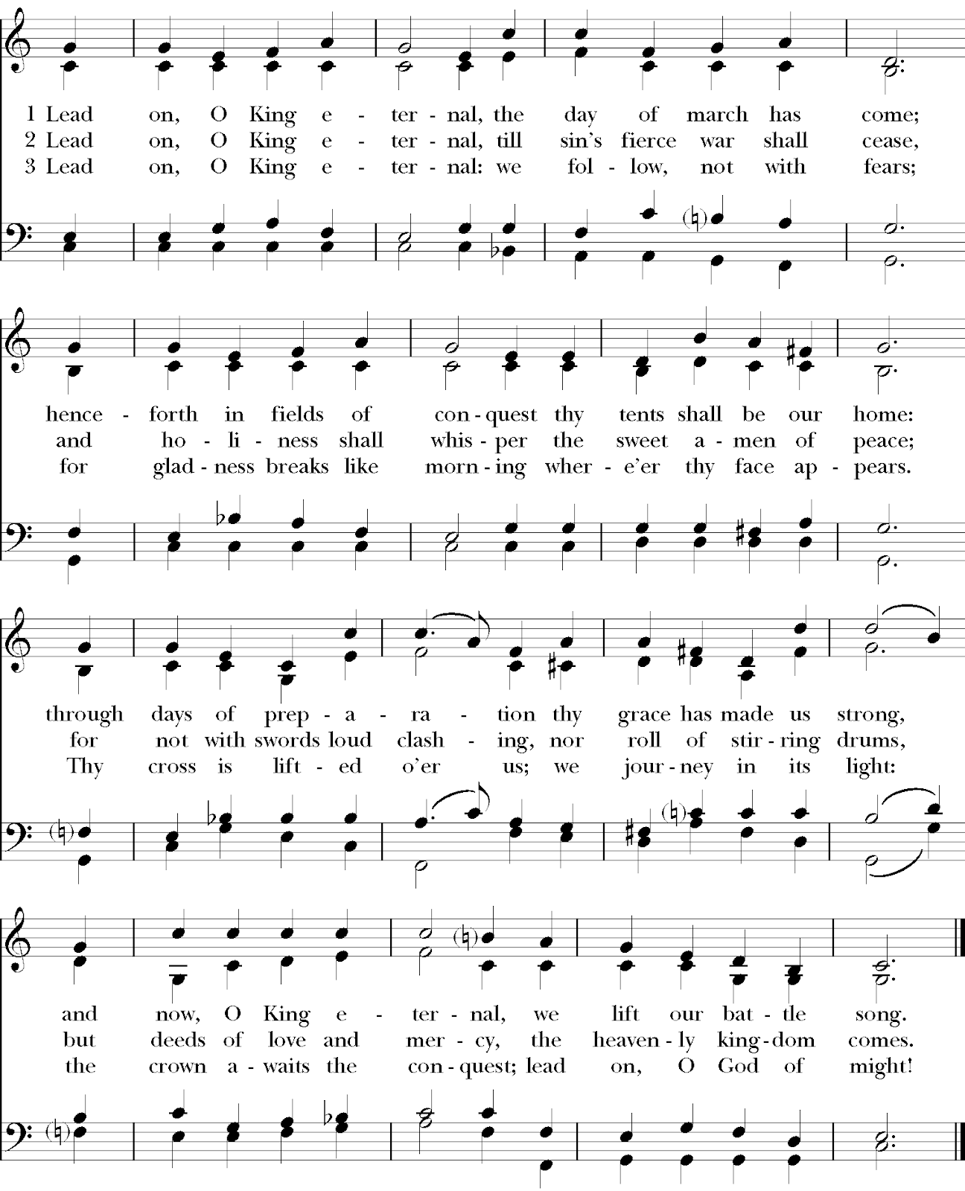

Let us bless the Lord.

**Thanks be to God.**

**HOST A STUDENT SUNDAY**

Next Sunday - September 28th

**Resident Sign-Up**

Name:

Email Address:

Phone Number:

Home Address:

Brunch - Lunch - Dinner (circle when you can host)

How many students can you host?

**Student Sign-Up**

Name:

Email Address:

Brunch – Lunch – Dinner (circle when available)

