

THE 18th SUNDAY

AFTER TRINITY



A SERVICE OF

HOLY COMMUNION

October 19, 2025

**GRACE NOTES – October 19, 2025**

**FIRST COMMUNION.** Will Retucci has been catechized and is prepared to receive the Lord’s Supper for the first time tonight!

**FALL SERMON SERIES.** We will be looking at the “I Am” statements of Jesus from the Gospel of John until All Saints Sunday.

**ALL SAINTS’ DAY POTLUCK.** If you are one of the ‘older’ folks attending Grace Anglican you are invited to a finger food potluck at 314 E. Butler St., Mercer, at 6:30PM on Saturday, November 1. This gathering will have an All Saints’ theme, and you’ll have the opportunity to share about a saint—a godly person—who has been a special blessing to you, whether one you read about or knew personally. As we announced last spring, we hope that by continuing to have similar gatherings three or four times a year we can build warm supportive relationships among Grace’s oldsters. Please reach out to Janice Brown at [Janicehudsonbrown@gmail.com](mailto:Janicehudsonbrown@gmail.com) or 724-992-8756 by Oct 27, if you can attend and what you might like to contribute to the meal.

**LECTURE AT TAS.** Trinity Anglican Seminary is hosting a lecture on October 30 at 7PM by Dr. Matthew Barrett. Come hear an exploration into how Anglican tradition - rooted in "mere Christianity" and the ancient creeds - offers a compelling vision for doctrinal fidelity today. Register for free at [tas.edu/rodgers](http://tas.edu/rodgers) and reach out to David if interested in carpooling to Ambridge.

**MONTHLY MISSION SPOTLIGHT** Promise of Life Network (Alpha & Omega Center) in Slippery Rock and New Castle helps families who are dealing with unexpected pregnancies.

**COLLEGE STUDENTS.** Please join the college ministry Telegram group with the QR code below.

**CHRISTIAN EDUCATION.** Please join us Sundays at 4PM for classes for all ages!

Next week, on October 26, Jeff Bilbro will begin a four-week adult series! We’ll reflect on how our citizenship in heaven and God’s call to love our neighbor here on earth should shape our engagement with the news. We’ll consider how the news might warp our attention, our sense of time, and belonging to the body of Christ.

**SABBATICAL.** Pastor Ethan was granted a sabbatical from mid-summer to mid-fall. Please pray for a season of refreshment for the entire Magness family.

**INFANT CARE ROOM.** The library is available as a dedicated space to care for your infants during the service. The livestream will also be available in this space during evening worship services.

**NURSERY.** We offer nursery for children (infants to three-year-olds) downstairs.

**THE CASA YOUTH MINISTRY** is on Tuesday nights at 7pm at Holy Trinity.

**NEED MEALS?** Are you in a situation in which you’d benefit from having people in the parish cook a few meals for you? Please use this QR Code and sign up!



**WAYS TO GIVE AT GRACE**

-Offering plate

-Mail: PO Box 45 Grove City PA 16127

-Venmo: GraceAnglicanChurch

-PayPal: [donate@graceanglicanonline.com](mailto:donate@graceanglicanonline.com)



**Opening Hymn:** I Sing the Mighty Power of God Words: Watts, 1715 Tune: Ellacombe

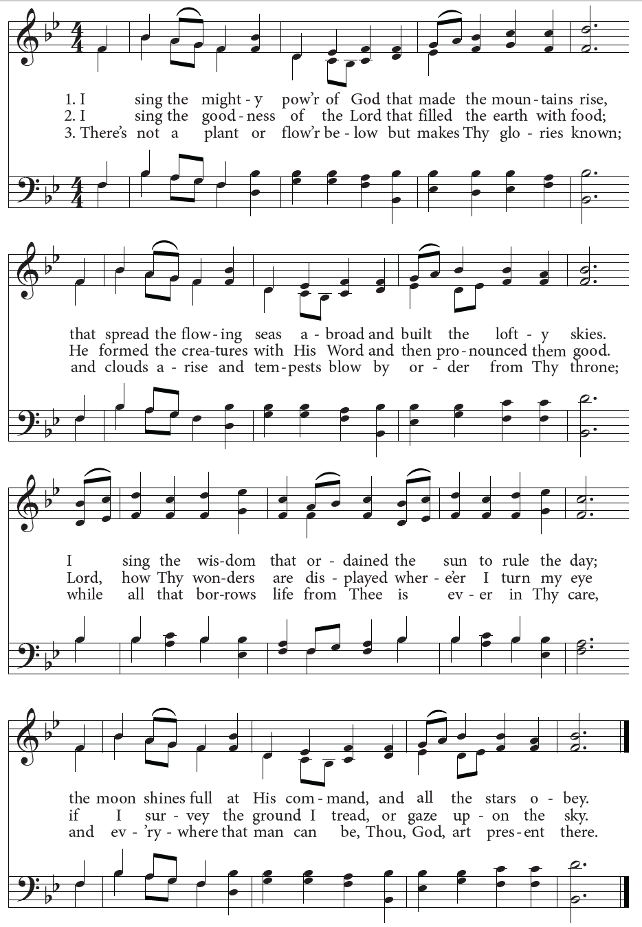

**Minister***.*  Blessed be God: the Father, the Son, & the Holy Spirit.

**Answer***.* And blessed be his Kingdom, now and forever. Amen.

**Minister**. Let us pray [together saying,

**The Collect for Purity***,*said by all

A

LMIGHTY God, to you all hearts are open, all desires known, and from you no secrets are hid: Cleanse the thoughts of our hearts by the inspiration of your Holy Spirit, that we may perfectly love you, and worthily magnify your holy Name; through Christ our Lord. Amen.

H

**The Summary of the Law**

EAR what our Lord Jesus Christ says. You shall love the Lord your God with all your heart, and with all your soul, and with all your mind. This is the first and great commandment. And the second is like it; You shall love your neighbor as your self. On these two commandments depend all the Law and the Prophets. -MATTHEW 22:37-40.

Lord, have mercy upon us. **Christ, have mercy upon us**. Lord, have mercy upon us.

A

LMIGHTY Lord and everlasting God, we beseech you to direct, sanctify, and govern, both our hearts and bodies, in the ways of your laws, and in the works of your commandments; that, through your most mighty protection, both here and always, we may be preserved in body and soul; through our Lord and Savior Jesus Christ. **Amen**.

**Minister***.* The Lord be with you.

**Answer***.* And with your spirit.

**Minister***.* Let us pray.

**Collect for the Eighteenth Sunday after Trinity**

Set us free, loving Father, from the bondage of our sins, and in your goodness and mercy give us the liberty of that abundant life which you have made known to us in our Savior Jesus Christ; who lives and reigns with you, in the unity of the Holy Spirit, one God, now and for ever. **Amen.**

**The Old Testament Lesson:** Exodus 33:12-23 (ESV)

**Reader**. A reading from the Book of Exodus.

**12**Moses said to the Lord, “See, you say to me, ‘Bring up this people,’ but you have not let me know whom you will send with me. Yet you have said, ‘I know you by name, and you have also found favor in my sight.’ **13**Now therefore, if I have found favor in your sight, please show me now your ways, that I may know you in order to find favor in your sight. Consider too that this nation is your people.” **14**And he said, “My presence will go with you, and I will give you rest.” **15**And he said to him, “If your presence will not go with me, do not bring us up from here. **16**For how shall it be known that I have found favor in your sight, I and your people? Is it not in your going with us, so that we are distinct, I and your people, from every other people on the face of the earth?” **17**And the Lord said to Moses, “This very thing that you have spoken I will do, for you have found favor in my sight, and I know you by name.” **18**Moses said, “Please show me your glory.” **19**And he said, “I will make all my goodness pass before you and will proclaim before you my name ‘The Lord.’ And I will be gracious to whom I will be gracious, and will show mercy on whom I will show mercy. **20**But,” he said, “you cannot see my face, for man shall not see me and live.” **21**And the Lord said, “Behold, there is a place by me where you shall stand on the rock, **22**and while my glory passes by I will put you in a cleft of the rock, and I will cover you with my hand until I have passed by. **23**Then I will take away my hand, and you shall see my back, but my face shall not be seen.”

**Reader**. The Word of the Lord. **Answer**. Thanks be to God.

**Psalm 121**

1 I will lift up my eyes unto the hills; *

from whence comes my help?

2 My help comes from the Lord, *

who has made heaven and earth.

3 He will not let your foot be moved, *

and he who keeps you will not sleep.

4 Behold, he who keeps Israel *

shall neither slumber nor sleep.

5 The Lord himself is your keeper; *

the Lord is your defense upon your right hand,

6 So that the sun shall not burn you by day, *

neither the moon by night.

7 The Lord shall preserve you from all evil; *

indeed, it is he who shall keep your soul.

8 The Lord shall preserve your going out and your coming in, *

from this time forth for evermore.

**The Gospel Lesson**: John 14:1-11 (ESV)

**Reader**. The Holy Gospel of our Lord Jesus Christ according to John.

**Answer**. Glory to you, Lord Christ.

1 “Let not your hearts be troubled. Believe in God; believe also in me. **2**In my Father's house are many rooms. If it were not so, would I have told you that I go to prepare a place for you? **3**And if I go and prepare a place for you, I will come again and will take you to myself, that where I am you may be also. **4**And you know the way to where I am going.” **5**Thomas said to him, “Lord, we do not know where you are going. How can we know the way?” **6**Jesus said to him, “I am the way, and the truth, and the life. No one comes to the Father except through me. **7**If you had known me, you would have known my Father also. From now on you do know him and have seen him.” **8**Philip said to him, “Lord, show us the Father, and it is enough for us.” **9**Jesus said to him, “Have I been with you so long, and you still do not know me, Philip? Whoever has seen me has seen the Father. How can you say, ‘Show us the Father’? **10**Do you not believe that I am in the Father and the Father is in me? The words that I say to you I do not speak on my own authority, but the Father who dwells in me does his works. **11**Believe me that I am in the Father and the Father is in me, or else believe on account of the works themselves.

**Reader**. The Gospel of the Lord. **Answer**. Praise to you, Lord Christ.

**The Sermon** The Rev’d David Beck

**The Nicene Creed**

LET us confess our faith in the words of the Nicene Creed:

W

E believe in one God, the Father, the Almighty, maker of heaven and earth, of all that is, visible and invisible.

WE believe in one Lord, Jesus Christ, the only-begotten Son of God, eternally begotten of the Father, God from God, Light from Light, true God from true God, begotten, not made, of one Being with the Father; through him all things were made. For us and for our salvation he came down from heaven, was incarnate from the Holy Spirit and the Virgin Mary, and was made man. For our sake he was crucified under Pontius Pilate; he suffered death and was buried. On the third day he rose again in accordance with the Scriptures; he ascended into heaven and is seated at the right hand of the Father. He will come again in glory to judge the living and the dead, and his kingdom will have no end.

WE believe in the Holy Spirit, the Lord, the giver of life, who proceeds from the Father and the Son, who with the Father and the Son is worshiped and glorified, who has spoken through the prophets. We believe in one holy catholic and apostolic Church. We acknowledge one Baptism for the forgiveness of sins. We look for the resurrection of the dead, and the life of the world to come. Amen.

**The Prayers**

Father, we pray for your holy catholic Church;

**That we all may be one in Christ.**

Grant that every member of the Church may truly and humbly serve you;

**That your Name may be glorified by all people.**

We pray for all bishops, priests, and deacons;

**That they may be faithful ministers of your Word and Sacraments.**

We pray for all who govern and hold authority in the nations of the world;

**That there may be justice and peace on the earth.**

Give us grace to do your will in all that we undertake, especially for the Promise of Life Network in Slippery Rock, as they help women and families with unplanned pregnancies.

**That our works may find favor in your sight.**

Have compassion on those who suffer from any grief or trouble;

**That they may be delivered from their distress.**

We praise you for your saints who have entered into joy;

**May we also come to share in your heavenly kingdom.**

Let us pray for our own needs and those of others. (The People may add their own petitions.)

Let us commend ourselves, and one another, and all our life to Christ our God. **For yours is the majesty, O Father, Son, and Holy Spirit;  yours is the kingdom and the power and the glory, now and forever.  Amen.**

A

**Invitation to Confession**

LL who truly and earnestly repent of your sins, and seek to live in love and charity with your neighbors, and intend to lead the new life, following the commandments of God, and walking in his holy ways: draw near with faith and make your humble confession to Almighty God.

A

**General Confession***,*said by all.

LMIGHTY God, Father of our Lord Jesus Christ, maker and judge of us all: We acknowledge and lament our many sins and offenses, which we have committed by thought, word, and deed against your divine majesty, provoking most justly your righteous anger against us. We are deeply sorry for these our transgressions; the burden of them is more than we can bear. Have mercy upon us, Have mercy upon us, most merciful Father; for your Son our Lord Jesus Christ’s sake, forgive us all that is past; and grant that we may evermore serve and please you in newness of life, to the honor and glory of your Name; through Jesus Christ our Lord. Amen.

A

**Absolution**

LMIGHTY God, our heavenly Father, who in his great mercy has promised forgiveness of sins to all those who sincerely repent and with true faith turn to him, have mercy upon you, pardon and deliver you from all your sins, confirm and strengthen you in all goodness, and bring you to everlasting life; through Jesus Christ our Lord.  **Amen.**

H

**The Comfortable Words**

EAR the comfortable words from the Word of God to all who truly turn to him.

Come to me, all who labor and are heavy laden, and I will give you rest.

-MATTHEW 11:28

God so loved the world, that he gave his only-begotten Son, that whoever believes in him should not perish but have eternal life. -JOHN 3:16

The saying is trustworthy and deserving of full acceptance, that Christ Jesus came into the world to save sinners. -1 TIMOTHY 1:15

If anyone sins, we have an advocate with the Father, Jesus Christ the righteous. He is the propitiation for our sins, and not for ours only, but also for the sins of the whole world. -1 JOHN 2:1-2

**Minister.** The peace of the Lord be always with you.

**People.** And with your spirit.

**Offering and Doxology** (tune: lasst uns erfreuen)

**The Sacrament of Holy Communion** (the 1662 Order)

**Minister**. The Lord be with you.

**Answer**. And with your spirit.

**Minister**. Lift up your hearts.

**Answer**. We lift them up to the Lord.

**Minister**. Let us give thanks to the Lord our God.

**Answer**. It is right to give Him thanks and praise.

I

T is right, our duty and our joy, always and everywhere to give thanks to you, Father Almighty, Creator of heaven and earth; Through Jesus Christ our Lord, who on the first day of the week overcame death and the grave, and by his glorious resurrection opened to us the way of everlasting life.

T

HEREFORE we praise you, joining our voices with Angels and Archangels and with all the company of heaven, who for ever sing this hymn to proclaim the glory of your Name: **Holy, holy, holy Lord God of power and might. Heaven and earth are full of your glory. Hosanna in the highest. Blessed is he who comes in the Name of the Lord. Hosanna in the highest.**

W

**The Prayer of Humble Access,** said by all, kneeling.

E do not presume to come to this your table, O merciful Lord, trusting in our own righteousness, but in your abundant and great mercies. We are not worthy so much as to gather up the crumbs under your table; but you are the same Lord whose character is always to have mercy. Grant us, therefore, gracious Lord, so to eat the flesh of your dear Son Jesus Christ, and to drink his blood, that our sinful bodies may be made clean by his body, and our souls washed through his most precious blood, and that we may evermore dwell in him, and he in us. Amen.

*The People continue to kneel. The minister stands and continues.*

A

LL praise and glory is yours, O God our heavenly Father, for in your tender mercy, you gave your only Son Jesus Christ to suffer death upon the Cross for our redemption. He made there, by his one oblation of himself once offered, a full, perfect, and sufficient sacrifice, oblation, and satisfaction, for the sins of the whole world; and he instituted, and in his Holy Gospel commanded us to continue, a perpetual memory of his precious death and sacrifice, until his coming again. Hear us, merciful Father, and grant that we receiving these gifts from your creation, this bread and this wine, according to your Son our Savior Jesus Christ’s institution, in remembrance of his death and passion, may be partakers of his most blessed Body and Blood; For on the night that he was betrayed, our Lord Jesus Christ took bread; and when he had given thanks, he broke it, and gave it to his disciples, saying, “Take, eat; this is my Body, which is given for you: Do this in remembrance of me.” Likewise, after supper, Jesus took the cup, and when he had given thanks, he gave it to them, saying, “Drink this, all of you; for this is my Blood of the New Covenant, which is shed for you, and for many, for the forgiveness of sins: Whenever you drink it, do this in remembrance of me.” **AMEN**.

**Invitation to Communion.** All baptized, believing Christians of an understanding age who areadmitted to the Sacrament within their own church are encouraged to receive it with us. St Paul in the New Testament requires some understanding of the Supper, instructing those who come to the Lord’s Supper to ‘discern’ the Body (that is, to have an understanding of the Lord’s Supper) as well as examine themselves before they commune. It is common Anglican practice that young children are to be catechized before receiving Communion (please contact a minister for the resources for catechism). Please come down the middle aisle to receive the bread, and then drink from either the common cup, or take and drink from a small cup of communion wine.

**Intercessory prayer** is available in the back of the nave in the church. This takes place during the distribution ofCommunion. You can come back for prayer for any reason whatsoever. If you want prayer for healing (physical or otherwise), you can also request anointing with oil (a biblical symbol for healing and restoration).

**Be Still, My Soul** Words: Katrina D. von Schlegel, 1752

1. Be still, my soul, the Lord is on thy side; bear patiently the cross of grief or pain;  
leave to thy God to order and provide; in every change he faithful will remain.  
Be still, my soul, thy best, thy heavenly Friend through thorny ways leads to a joyful end.  
  
2. Be still, my soul, thy God doth undertake to guide the future as he has the past.  
Thy hope, thy confidence let nothing shake; all now mysterious shall be bright at last.  
Be still, my soul, the waves and winds still know

his voice who ruled them while he dwelt below.  
  
3. Be still, my soul, when dearest friends depart, and all is darkened in the veil of tears,  
then shalt thou better know his love, his heart, who comes to soothe thy sorrow and thy fears.  
Be still, my soul, thy Jesus can repay, from his own fullness, all he takes away.  
  
4. Be still, my soul, the hour is hastening on when we shall be forever with the Lord,  
when disappointment, grief and fear are gone, sorrow forgot, love's purest joys restored.  
Be still, my soul, when change and tears are past, all safe and blessed we shall meet at last.

**Grace Greater Than Our Sin** Words: Julia H. Johnston, 1911 Music: Daniel B. Towner   
1. Marvelous grace of our loving Lord, Grace that exceeds our sin and our guilt!  
Yonder on Calvary's mount out-poured, There where the blood of the Lamb was spilt.

*Refrain:*Grace, grace, God's grace, Grace that will pardon and cleanse within;  
Grace, grace, God's grace, Grace that is greater than all our sin!

2. Sin and despair, like the sea-waves cold, Threaten the soul with infinite loss;  
Grace that is greater– yes, grace untold– Points to the Refuge, the mighty Cross. (Refrain)

3. Dark is the stain that we cannot hide, What can avail to wash it away?

Look! There is flowing a crimson tide, Whiter than snow you may be today. (Refrain)

4. Marvelous, infinite, matchless grace, Freely bestowed on all who believe!  
All who are longing to see His face, Will you this moment His grace receive? (Refrain)

**Jesus Paid it All** Words and Tune: Hall, 1865

1. I hear the Savior say, “Thy strength indeed is small;  
Child of weakness, watch and pray, find in Me thine all in all

**Refrain:** Jesus paid it all, All to Him I owe;

sin had left a crimson stain, he washed it white as snow.

2. For nothing good have I, whereby Thy grace to claim,  
I’ll wash my garments white in the blood of Calvary’s Lamb.

3. And when, before the throne, I stand in Him complete,  
"Jesus died my soul to save," my lips shall still repeat.

4. Lord, now indeed I find thy power and thine alone,  
Can change the leper’s spots and melt the heart of stone.

**The Lord’s Prayer,** said by all

And now, as our Savior Christ has taught us, we are bold to pray,

O

UR Father, Who art in heaven, hallowed be thy Name, thy kingdom come, thy will be done, on earth as it is in heaven. Give us this day our daily bread. And forgive us our trespasses, as we forgive those who trespass against us. And lead us not into temptation, but deliver us from evil. For Thine is the kingdom, and the power, and the glory, forever and ever. Amen.

A

**Post-Communion Prayer**, said by all

LMIGHTY God, we thank you for feeding us with the spiritual food  
of the body and blood of your Son Jesus Christ. Through him we offer you our souls and bodies to be a living sacrifice. Send us out into the world  
in the power of your Spirit, to live and work to your praise and glory. Amen.

T

**The Blessing**

HE PEACE OF GOD, which passes all understanding, keep your hearts and minds in the knowledge and love of God, and of His Son Jesus Christ our Lord: And the Blessing of God Almighty, the Father, the Son and the Holy Spirit, be among you, and remain with you always. **Amen.**

**Closing Hymn:** Hail to the Lord’s Anointed   Words: James Montgomery, 1822

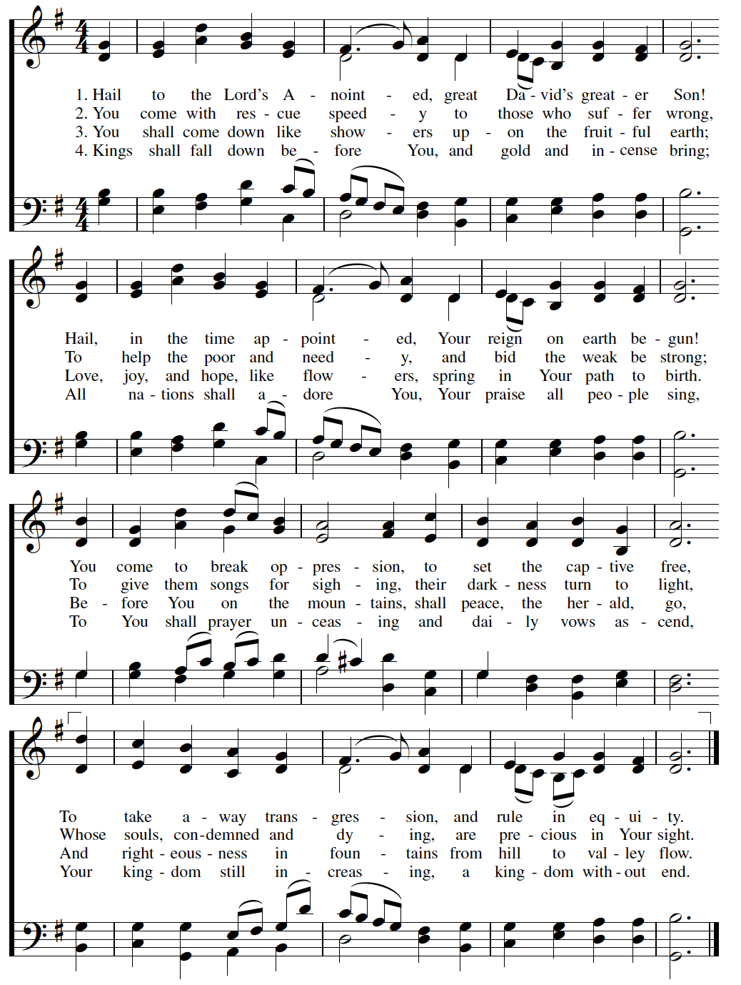

Let us bless the Lord.

**Thanks be to God.**

**GRACE’S STAFF**

**RECTOR**. The Rev’d Ethan Magness is lead-minister at Grace, the principal preacher and teacher, who plans and coordinates worship, leads the staff and vestry, administrates the parish, offers pastoral care and counsel, and marries, buries, etc. (emagness@graceanglicanonline.com)

**DIRECTOR OF FAMILY MINISTRIES**. Mr. Steve Matson creates, oversees, and develops ministries related to children, youth, and their families; and assists with pastoral care. (smatson@graceanglicanonline.com)

**ASSISTANT MINISTER FOR COLLEGE MINISTRY.** The Rev’d Cn. Dr Don Shepson has a part-time position with Grace and works with college students, leads Bible studies, and does pastoral care, counseling, preaching, etc. (dshepson@graceanglicanonline.com)

**ASSISTANT RECTOR.** The Rev’d David Beck assists with the duties of the parish, primarily with preaching, pastoral care, mission, and cell groups. (dbeck@graceanglicanonline.com).

**PARISH ADMINISTRATOR**. Alayna VanKirk serves as our parish administrator, organizing and training volunteers and keeping the parish schedule, prints bulletins, and keeps the parish calendar. (akirk@graceanglicanonline.com)

**WOMEN’S MINISTRY & HOSPITALITY COORDINATOR**. Melissa Cowan leads, oversees, and develops ministries for women, parish hospitality, and new-comer integration.

(mcowan@graceanglicanonline.com)

**MUSICIAN**. Bethany Mayo coordinates, trains, and rehearses with the music team, and leads our music (bmayo@graceanglicanonline.com)

**LIVE-STREAM & AUDIO TECH**. Matt Barber runs our live-streaming services. (ink_well2004@yahoo.com)

**CHILDREN’S MINISTRY COORDINATOR.** Kristen Schools serves part time and helps lead the children’s ministry program and events. kschools@graceanglicanonline.com ).

**GRACE’S VESTRY**

Ken Smith (Senior Warden) Randy Welker Rob Mueller (Junior Warden)

Emily Jefferis Cindy Marsch (secretary) Chris Franklin

**\*Treasurer (non-vestry):** Gabe Gordon

