

THE 21st SUNDAY
AFTER TRINITY



A SERVICE OF
HOLY COMMUNION

November 9, 2025

GRACE NOTES – November 9, 2025

SERVICE FOR SUSAN BROWN. A service will be held Saturday, November 22 at 11AM at Crossroads Ministries (81 Walter Long Rd. Finleyville, PA 15332). A luncheon will follow at 12PM.

COMMON CUP. Today we return to the standard Anglican practice of receiving Communion wine from one common cup. There are a few small cups available for people with dietary restrictions or serious health concerns.

WE NEED YOU. We need more volunteers at Grace to support our church, ranging from hospitality to Communion setup to musicians. Please pick up and fill out the interest form from the welcome table!

MONTHLY MISSION SPOTLIGHT. SutiSana provides dignified employment in a just and thriving business and helps to fight human trafficking and commercial exploitation.

COLLEGE STUDENTS. Please join the college ministry Telegram group with the QR code below.


CHRISTIAN EDUCATION. Please join us Sundays at 4PM for classes for all ages!

Jeff Bilbro is currently teaching a four-week adult series! We’ll reflect on how our citizenship in heaven and God’s call to love our neighbor here on earth should shape our engagement with the news. We’ll consider how the news might warp our attention, our sense of time, and belonging to the body of Christ.

SABBATICAL. Pastor Ethan was granted a sabbatical until November 16. Please pray for Ethan and the Magness family as he returns to ministry soon.

INFANT CARE ROOM. The library is available as a dedicated space to care for your infants during the service. The livestream will also be available in this space during evening worship services.

NURSERY. We offer nursery for children (infants to three-year-olds) downstairs.

THE CASA YOUTH MINISTRY is on Tuesday nights at 7pm at Holy Trinity.

PASTORAL CARE. Please reach out to Pastor David for any pastoral care needs at dbeck@graceanglicanonline.com or 810-772-8291.

WAYS TO GIVE AT GRACE
-Offering plate
-Mail: PO Box 45 Grove City PA 16127
-Venmo: GraceAnglicanChurch
-PayPal: donate@graceanglicanonline.com

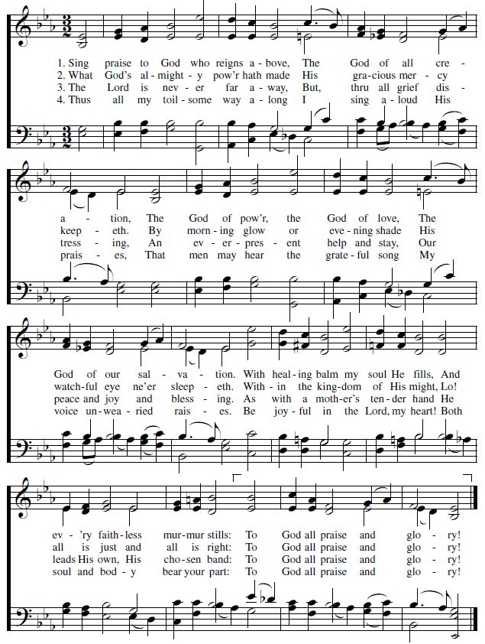Opening Hymn: Sing Praise to God Who Reigns Above Words: Schutz, 1566 Tune: Kirchengesänge

Minister. Blessed be God: the Father, the Son, & the Holy Spirit.
Answer. And blessed be his Kingdom, now and forever. Amen.
Minister. Let us pray [together saying,]

The Collect for Purity, said by all
A
LMIGHTY God, to you all hearts are open, all desires known, and from you no secrets are hid: Cleanse the thoughts of our hearts by the inspiration of your Holy Spirit, that we may perfectly love you, and worthily magnify your holy Name; through Christ our Lord. Amen.

H
The Summary of the Law
EAR what our Lord Jesus Christ says. You shall love the Lord your God with all your heart, and with all your soul, and with all your mind. This is the first and great commandment. And the second is like it; You shall love your neighbor as your self. On these two commandments depend all the Law and the Prophets. -MATTHEW 22:37-40.

Lord, have mercy upon us. Christ, have mercy upon us. Lord, have mercy upon us.

A
LMIGHTY Lord and everlasting God, we beseech you to direct, sanctify, and govern, both our hearts and bodies, in the ways of your laws, and in the works of your commandments; that, through your most mighty protection, both here and always, we may be preserved in body and soul; through our Lord and Savior Jesus Christ. Amen.

Minister. The Lord be with you.
Answer. And with your spirit.
Minister. Let us pray.

The Collect for Twenty-First Sunday after Trinty
O God, whose blessed Son came into the world that he might destroy the works of the devil and make us children of God and heirs of eternal life: Grant that, having this hope, we may purify ourselves as he is pure; that, when he comes again with power and great glory, we may be made like him in his eternal and glorious kingdom; where he lives and reigns with you and the Holy Spirit, one God, for ever and ever. Amen.

The Old Testament Lesson: Job 19:23-27 (ESV)
Reader. A reading from the Book of Job.

²³ “Oh that my words were written! Oh that they were inscribed in a book! ²⁴ Oh that with an iron pen and lead they were engraved in the rock forever! ²⁵ For I know that my Redeemer lives, and at the last he will stand upon the earth. ²⁶ And after my skin has been thus destroyed, yet in my flesh I shall see God, ²⁷ whom I shall see for myself, and my eyes shall behold, and not another. My heart faints within me!

Reader. The Word of the Lord. Answer. Thanks be to God.

Psalm 17: 1-6
1 Hear what is right, O Lord; consider my complaint; *
hearken to my prayer, which does not come from lying lips.
2 Let justice for me come forth from your presence, *
and let your eyes look upon that which is right.
3 You have tested and visited my heart in the night season. *
If you try me you shall find no wickedness in me; my mouth shall not
offend.
4 As for the works of others, *
because of the words of your lips, I have kept myself from the ways of the
violent.
5 Hold my steps firmly in your paths, *
that my footsteps may not slip.
6 I have called upon you, O God, for you will hear me; *
incline your ear to me and hearken to my words.

The Gospel Lesson: Luke 20:27-38 (ESV)
Reader. The Holy Gospel of our Lord Jesus Christ according to Luke.
Answer. Glory to you, Lord Christ.

²⁷ There came to him some Sadducees, those who deny that there is a resurrection, ²⁸ and they asked him a question, saying, “Teacher, Moses wrote for us that if a man's brother dies, having a wife but no children, the man must take the widow and raise up offspring for his brother. ²⁹ Now there were seven brothers. The first took a wife, and died without children. ³⁰ And the second ³¹ and the third took her, and likewise all seven left no children and died. ³² Afterward the woman also died. ³³ In the resurrection, therefore, whose wife will the woman be? For the seven had her as wife.” ³⁴ And Jesus said to them, “The sons of this age marry and are given in marriage, ³⁵ but those who are considered worthy to attain to that age and to the resurrection from the dead neither marry nor are given in marriage, ³⁶ for they cannot die anymore, because they are equal to angels and are sons of God, being sons of the resurrection. ³⁷ But that the dead are raised, even Moses showed, in the passage about the bush, where he calls the Lord the God of Abraham and the God of Isaac and the God of Jacob. ³⁸ Now he is not God of the dead, but of the living, for all live to him.”

Reader. The Gospel of the Lord. Answer. Praise to you, Lord Christ.

The Sermon The Rev’d Chad Lawrence

The Nicene Creed
LET us confess our faith in the words of the Nicene Creed:
W

E believe in one God, the Father, the Almighty, maker of heaven and earth, of all that is, visible and invisible.

WE believe in one Lord, Jesus Christ, the only-begotten Son of God, eternally begotten of the Father, God from God, Light from Light, true God from true God, begotten, not made, of one Being with the Father; through him all things were made. For us and for our salvation he came down from heaven, was incarnate from the Holy Spirit and the Virgin Mary, and was made man. For our sake he was crucified under Pontius Pilate; he suffered death and was buried. On the third day he rose again in accordance with the Scriptures; he ascended into heaven and is seated at the right hand of the Father. He will come again in glory to judge the living and the dead, and his kingdom will have no end.

WE believe in the Holy Spirit, the Lord, the giver of life, who proceeds from the Father and the Son, who with the Father and the Son is worshiped and glorified, who has spoken through the prophets. We believe in one holy catholic and apostolic Church. We acknowledge one Baptism for the forgiveness of sins. We look for the resurrection of the dead, and the life of the world to come. Amen.

The Prayers
Father, we pray for your holy catholic Church;
That we all may be one in Christ.

Grant that every member of the Church may truly and humbly serve you;
That your Name may be glorified by all people.

We pray for all bishops, priests, and deacons;
That they may be faithful ministers of your Word and Sacraments.

We pray for all who govern and hold authority in the nations of the world;
That there may be justice and peace on the earth.

Give us grace to do your will in all that we undertake, especially SutiSana in Bolivia, as they help fight human trafficking and commercial exploitation.
That our works may find favor in your sight.

Have compassion on those who suffer from any grief or trouble;
That they may be delivered from their distress.

We praise you for your saints who have entered into joy;
May we also come to share in your heavenly kingdom.

Let us pray for our own needs and those of others. (The People may add their own petitions.)

Let us commend ourselves, and one another, and all our life to Christ our God. For yours is the majesty, O Father, Son, and Holy Spirit; yours is the kingdom and the power and the glory, now and forever. Amen.

A
Invitation to Confession
LL who truly and earnestly repent of your sins, and seek to live in love and charity with your neighbors, and intend to lead the new life, following the commandments of God, and walking in his holy ways: draw near with faith and make your humble confession to Almighty God.

A
General Confession, said by all.
LMIGHTY God, Father of our Lord Jesus Christ, maker and judge of us all: We acknowledge and lament our many sins and offenses, which we have committed by thought, word, and deed against your divine majesty, provoking most justly your righteous anger against us. We are deeply sorry for these our transgressions; the burden of them is more than we can bear. Have mercy upon us, Have mercy upon us, most merciful Father; for your Son our Lord Jesus Christ’s sake, forgive us all that is past; and grant that we may evermore serve and please you in newness of life, to the honor and glory of your Name; through Jesus Christ our Lord. Amen.
A
Absolution
LMIGHTY God, our heavenly Father, who in his great mercy has promised forgiveness of sins to all those who sincerely repent and with true faith turn to him, have mercy upon you, pardon and deliver you from all your sins, confirm and strengthen you in all goodness, and bring you to everlasting life; through Jesus Christ our Lord. Amen.

H
The Comfortable Words
EAR the comfortable words from the Word of God to all who truly turn to him.
Come to me, all who labor and are heavy laden, and I will give you rest.
-MATTHEW 11:28

God so loved the world, that he gave his only-begotten Son, that whoever believes in him should not perish but have eternal life. -JOHN 3:16

The saying is trustworthy and deserving of full acceptance, that Christ Jesus came into the world to save sinners. -1 TIMOTHY 1:15

If anyone sins, we have an advocate with the Father, Jesus Christ the righteous. He is the propitiation for our sins, and not for ours only, but also for the sins of the whole world. -1 JOHN 2:1-2

Minister. The peace of the Lord be always with you.
People. And with your spirit.

Offering and Doxology (tune: lasst uns erfreuen)

The Sacrament of Holy Communion (the 1662 Order)

Minister. The Lord be with you.
Answer. And with your spirit.
Minister. Lift up your hearts.
Answer. We lift them up to the Lord.
Minister. Let us give thanks to the Lord our God.
Answer. It is right to give Him thanks and praise.

I
T is right, our duty and our joy, always and everywhere to give thanks to you, Father Almighty, Creator of heaven and earth; Through Jesus Christ our Lord, who on the first day of the week overcame death and the grave, and by his glorious resurrection opened to us the way of everlasting life.

T
HEREFORE we praise you, joining our voices with Angels and Archangels and with all the company of heaven, who for ever sing this hymn to proclaim the glory of your Name: Holy, holy, holy Lord God of power and might. Heaven and earth are full of your glory. Hosanna in the highest. Blessed is he who comes in the Name of the Lord. Hosanna in the highest.

W
The Prayer of Humble Access, said by all, kneeling.
E do not presume to come to this your table, O merciful Lord, trusting in our own righteousness, but in your abundant and great mercies. We are not worthy so much as to gather up the crumbs under your table; but you are the same Lord whose character is always to have mercy. Grant us, therefore, gracious Lord, so to eat the flesh of your dear Son Jesus Christ, and to drink his blood, that our sinful bodies may be made clean by his body, and our souls washed through his most precious blood, and that we may evermore dwell in him, and he in us. Amen.

The People continue to kneel. The minister stands and continues.
A
LL praise and glory is yours, O God our heavenly Father, for in your tender mercy, you gave your only Son Jesus Christ to suffer death upon the Cross for our redemption. He made there, by his one oblation of himself once offered, a full, perfect, and sufficient sacrifice, oblation, and satisfaction, for the sins of the whole world; and he instituted, and in his Holy Gospel commanded us to continue, a perpetual memory of his precious death and sacrifice, until his coming again. Hear us, merciful Father, and grant that we receiving these gifts from your creation, this bread and this wine, according to your Son our Savior Jesus Christ’s institution, in remembrance of his death and passion, may be partakers of his most blessed Body and Blood; For on the night that he was betrayed, our Lord Jesus Christ took bread; and when he had given thanks, he broke it, and gave it to his disciples, saying, “Take, eat; this is my Body, which is given for you: Do this in remembrance of me.” Likewise, after supper, Jesus took the cup, and when he had given thanks, he gave it to them, saying, “Drink this, all of you; for this is my Blood of the New Covenant, which is shed for you, and for many, for the forgiveness of sins: Whenever you drink it, do this in remembrance of me.” AMEN.
Invitation to Communion. All baptized, believing Christians of an understanding age who are admitted to the Sacrament within their own church are encouraged to receive it with us. St Paul in the New Testament requires some understanding of the Supper, instructing those who come to the Lord’s Supper to ‘discern’ the Body (that is, to have an understanding of the Lord’s Supper) as well as examine themselves before they commune. It is common Anglican practice that young children are to be catechized before receiving Communion (please contact a minister for the resources for catechism). Please come down the middle aisle to receive the bread, and then drink from either the common cup, or take and drink from a small cup of communion wine.

Intercessory prayer is available in the back of the nave in the church. This takes place during the distribution of Communion. You can come back for prayer for any reason whatsoever. If you want prayer for healing (physical or otherwise), you can also request anointing with oil (a biblical symbol for healing and restoration).

Amazing Grace Words: John Newton, 1779
1. Amazing grace! How sweet the sound that saved a wretch like me!
I once was lost, but now am found; was blind, but now I see.

2. ‘Twas grace that taught my heart to fear, and grace my fears relieved;
How precious did that grace appear the hour I first believed!

3. Through many dangers, toils and snares, I have already come;
’Tis grace hath brought me safe thus far, and grace will lead me home.

4. The Lord has promised good to me; his word my hope secures
He will my shield and portion be as long as life endures.

5. Redeeming Christ, whose blood-bought sons, now run a toilsome race
Will soon, to us, grant Sabbath rest, and offer God’s embrace.

6. When we’ve been there ten thousand years, bright shining as the sun,
We’ve no less days to sing God’s praise than when we’d first begun.

I am the Bread of Life Words and Music: Toolan, 1966
1. I am the bread of life, He who comes to Me shall not hunger,
He who believes in Me shall not thirst.
No one can come to Me, Unless the Father draws him.

Chorus:
And I will raise him up, I will raise him up, and I will raise him up on the last day.

2. The bread that I will give is My flesh for the life of the world,
And he who eats of this bread, He shall live for ever, He shall live for ever.

3. I am the resurrection, And I am the life,
He who believes in Me, Even if he dies, He shall live for ever.
The Goodness of God
1. I love You, Lord. Oh, Your mercy never failed me
All my days, I've been held in Your hands
From the moment that I wake up Until I lay my head
Oh, I will sing of the goodness of God
Chorus:
And all my life You have been faithful;
And all my life You have been so, so good
With every breath that I am able, Oh, I will sing of the goodness of God
2. I love Your voice. You have led me through the fire
And in darkest night You are close like no other
I've known You as a Father, I've known You as a Friend
And I have lived in the goodness of God. (Chorus)

3. I love your cross; You have bought us with a ransom
You shed your blood; reconciled us with the Father.
You search for us and find us and then you bring us home.
And we are saved by the goodness of God (Chorus)

Bridge: Your goodness is running after, it’s running after me
Your goodness is running after, it’s running after me
With my life laid down, I’m surrendered now, I give You everything
Your goodness is running after, it’s running after me (Chorus)

The Lord’s Prayer, said by all
And now, as our Savior Christ has taught us, we are bold to pray,
O
UR Father, Who art in heaven, hallowed be thy Name, thy kingdom come, thy will be done, on earth as it is in heaven. Give us this day our daily bread. And forgive us our trespasses, as we forgive those who trespass against us. And lead us not into temptation, but deliver us from evil. For Thine is the kingdom, and the power, and the glory, forever and ever. Amen.

A
Post-Communion Prayer, said by all
LMIGHTY God, we thank you for feeding us with the spiritual food
of the body and blood of your Son Jesus Christ. Through him we offer you our souls and bodies to be a living sacrifice. Send us out into the world
in the power of your Spirit, to live and work to your praise and glory. Amen.

The Blessing
THE PEACE OF GOD, which passes all understanding, keep your hearts and minds in the knowledge and love of God, and of His Son Jesus Christ our Lord: And the Blessing of God Almighty, the Father, the Son and the Holy Spirit, be among you, and remain with you always. Amen.

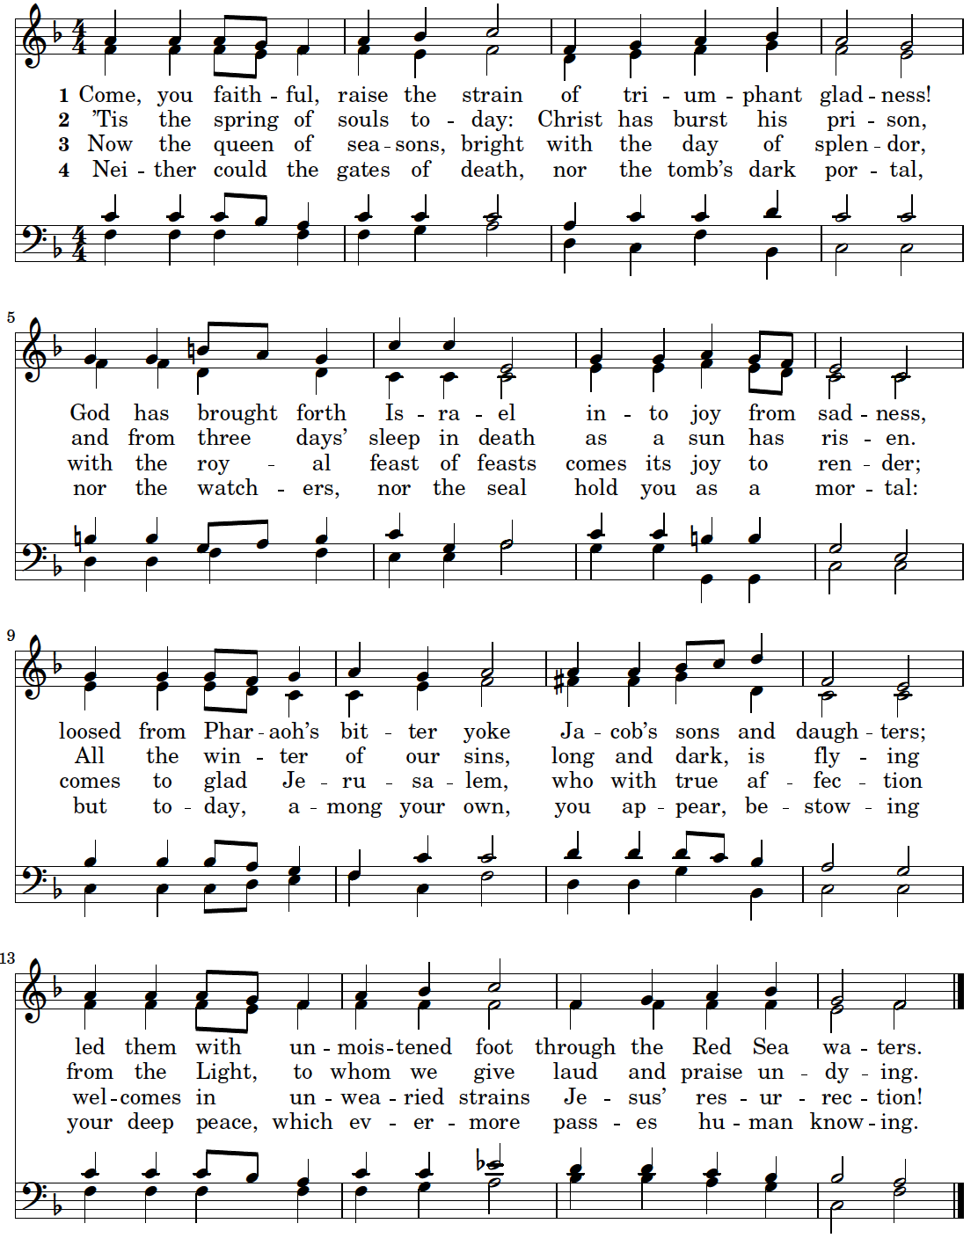Closing Hymn: Come, Ye Faithful, Raise the Strain Words: John of Damascus, 8th cent.

Let us bless the Lord.
Thanks be to God.

GRACE’S STAFF

RECTOR. The Rev’d Ethan Magness is lead-minister at Grace, the principal preacher and teacher, who plans and coordinates worship, leads the staff and vestry, administrates the parish, offers pastoral care and counsel, and marries, buries, etc. (emagness@graceanglicanonline.com)

DIRECTOR OF FAMILY MINISTRIES. Mr. Steve Matson creates, oversees, and develops ministries related to children, youth, and their families; and assists with pastoral care. (smatson@graceanglicanonline.com)

ASSISTANT MINISTER FOR COLLEGE MINISTRY. The Rev’d Cn. Dr Don Shepson has a part-time position with Grace and works with college students, leads Bible studies, and does pastoral care, counseling, preaching, etc. (dshepson@graceanglicanonline.com)

ASSISTANT RECTOR. The Rev’d David Beck assists with the duties of the parish, primarily with preaching, pastoral care, mission, and cell groups. (dbeck@graceanglicanonline.com).

PARISH ADMINISTRATOR. Alayna VanKirk serves as our parish administrator, organizing and training volunteers and keeping the parish schedule, prints bulletins, and keeps the parish calendar. (akirk@graceanglicanonline.com)

WOMEN’S MINISTRY & HOSPITALITY COORDINATOR. Melissa Cowan leads, oversees, and develops ministries for women, parish hospitality, and new-comer integration.
(mcowan@graceanglicanonline.com)

MUSICIAN. Bethany Mayo coordinates, trains, and rehearses with the music team, and leads our music (bmayo@graceanglicanonline.com)

LIVE-STREAM & AUDIO TECH. Matt Barber runs our live-streaming services. (ink_well2004@yahoo.com)

CHILDREN’S MINISTRY COORDINATOR. Kristen Schools serves part time and helps lead the children’s ministry program and events. kschools@graceanglicanonline.com ).

GRACE’S VESTRY
Ken Smith (Senior Warden) Randy Welker Rob Mueller (Junior Warden)
Emily Jefferis Cindy Marsch (secretary) Chris Franklin

*Treasurer (non-vestry): Gabe Gordon



