

THE 3rd SUNDAY OF
EPIPHANY



A SERVICE OF
HOLY COMMUNION

January 25, 2026

GRACE NOTES – January 25, 2026

r
ANNUAL MEETING. Join us on January 25 at 3:30 pm for our Annual Meeting. This encouraging time together includes vestry elections, presentations from the staff and treasurer, and is accompanied by light refreshments. Everyone is welcome to attend and members are eligible to vote in the vestry election.

GIVING STATEMENTS regarding your financial giving to Grace during 2025 will be sent to you by the end of January.

CELL GROUPS are HERE! Check out the bulletin insert for more info!

WE WELCOME PASTOR PETE EVERETT to the pulpit. Pete is a pastor-in-residence here at Grace, having recently retired from Grace Church in Harmony, PA. He’s been a good friend of Ethan (and Eric Rodes!) from way-back-when. Glad to have you here, Pete (and his wife, Sandi).

RE-THINKING CHRISTIAN HOSP-ITALITY. Join us on for a three-Sunday Christian education series (Feb 8, 15, 22) at 4pm as we study of scriptural teaching on the necessity and nature of godly hospitality, probing the complex implications of Invitation, the need to accept Inadequacy and honor Individuality, and the goal of approaching Intimacy. Janice Brown will teach the class, and it’ll change how you see your home and engage your guests. Please join us!

WOMEN’S MOVIE NIGHT. Feb 7th at 6:30pm in the Fellowship Hall of Holy Trinity Lutheran. Bring a portable chair! RSVP to Melissa Cowan is appreciated but not required!

CHANCEL GUILD (COMMUNION SET-UP). We need help from people who are willing to be trained to set up / tear down the Communion Table. Contact Alayna if interested.
CHILDREN’S LITURGY. During the evening service for children ages 3-6. The following Sundays there will be no class: Feb 1, March 8, April 5, May 3, May 24. June 14th being the last class till August.

STOLES FOR BYRCE LOWE. When we support a seminarian who is ordained, our parish helps to pay for stoles for that newly minted/deacon or priest. We are raising money to purchase stoles for Bryce. If you’re interested in donating, you can give to Grace and put ‘Bryce’s stoles” in the memo-line of a check or give online and demarcate it for “Bryce’s stoles.”

MONTHLY MISSION MOMENT. Schuyler Kitchin serves as a campus minister with InterVarsity at Berklee College of Music and other arts schools in the Boston area. Now in his fifth year with IV, Schuyler ministers to students through Bible study, discipleship opportunities, mentoring of student leaders, and outreach of various kinds. This fall he experienced a particularly challenging time in his ministry. Pray for refreshment and encouragement for Schuyler and the student leaders serving with him.

INFANT CARE ROOM. The library is available as a dedicated space to care for your infants during the service. The livestream is available in this space during evening services.

NURSERY. We offer nursery for children (infants to three-year-olds) downstairs.

THE CASA YOUTH MINISTRY is on Tuesday nights at 7pm at Holy Trinity.

WAYS TO GIVE AT GRACE
-Offering plate
-Mail: PO Box 45 Grove City PA 16127
-Venmo: GraceAnglicanChurch
-PayPal: donate@graceanglicanonline.com

Processional Hymn: Alleluia! Sing to Jesus! Words: Dix, 1866 Tune: Hypherdol

1. Alleluia! sing to Jesus! His the scepter, His the throne.
Alleluia! His the triumph, His the victory alone.
Hark! the songs of peaceful Zion thunder like a mighty flood.
Jesus out of every nation hath redeemed us by His blood!

2. Alleluia! not as orphans are we left in sorrow now;
Alleluia! He is near us, faith believes, nor questions how;
Though the cloud from sight received Him when the forty days were o’er
Shall our hearts forget His promise, I am with you evermore?

3. Alleluia! bread of heaven, Thou on earth our food, our stay;
Alleluia! here the sinful flee to Thee from day to day:
Intercessor, friend of sinners, Earth’s Redeemer, plead for me,
Where the songs of all the sinless sweep across the crystal sea.

4. Alleluia! Best of Shepherds, pilgrim seeking those astray
Alleluia! Striving onward t’ward us as we fled away.
Searching ‘midst our ruined cities, barren valleys wet with tears.
Takes us back to greener pastures where we dwell for endless years.

5. Alleluia! sing to Jesus! His the scepter, His the throne.
Alleluia! His the triumph, His the victory alone.
Hark! the songs of holy Zion thunder like a mighty flood.
Jesus out of every nation hath redeemed us by His blood!


Minister. I will make you as a light for the nations,
Answer. That my salvation may reach to the end of the earth.
Minister. Let us pray.

The Collect for Purity, said by all
A
LMIGHTY God, to you all hearts are open, all desires known, and from you no secrets are hid: Cleanse the thoughts of our hearts by the inspiration of your Holy Spirit, that we may perfectly love you, and worthily magnify your holy Name; through Christ our Lord. Amen.

H
The Summary of the Law
EAR what our Lord Jesus Christ says. You shall love the Lord your God with all your heart, and with all your soul, and with all your mind. This is the first and great commandment. And the second is like it; You shall love your neighbor as your self. On these two commandments depend all the Law and the Prophets. MATTHEW 22:37-40.

Lord, have mercy upon us.
Christ, have mercy upon us.
Lord, have mercy upon us.

A
LMIGHTY Lord and everlasting God, we beseech you to direct, sanctify, and govern, both our hearts and bodies, in the ways of your laws, and in the works of your commandments; that, through your most mighty protection, both here and always, we may be preserved in body and soul; through our Lord and Savior Jesus Christ. Amen.

Song of Praise: There is a Redeemer Words & Tune: Keith Green, 1982

1. There is a redeemer, Jesus, God's own Son, Precious Lamb of God, Messiah, Holy One
Thank you O my Father for giving us Your Son
And leaving Your Spirit til the work on earth is done
2. Jesus my redeemer name above all names, precious lamb of God, Messiah, hope for sinners slain
3. When I stand in Glory, I will see His face, there I'll serve my King forever in that Holy Place.

Minister. The Lord be with you.
Answer. And with your spirit.
Minister. Let us pray.

G
The Collect for the 3rd Sunday of Epiphany
IVE us grace, O Lord, to answer readily the call of our Savior Jesus Christ and proclaim to all people the Good News of his salvation, that we and the whole world may perceive the glory of his marvelous works; who lives and reigns with you and the Holy Spirit, one God, for ever and ever. Amen.

The Epistle Lesson: I Corinthians 1:10-17 (ESV)
Reader. A reading from the first letter of Paul to the church in Corinth.

I

appeal to you, brothers, by the name of our Lord Jesus Christ, that all of you agree, and that there be no divisions among you, but that you be united in the same mind and the same judg-ment. ¹¹ For it has been reported to me by Chloe's people that there is quarreling among you, my brothers. ¹² What I mean is that each one of you says, “I follow Paul,” or “I follow Apollos,” or “I follow Cephas,” or “I follow Christ.” ¹³ Is Christ divided? Was Paul crucified for you? Or were you baptized in the name of Paul? ¹⁴ I thank God that I baptized none of you except Crispus and Gaius, ¹⁵ so that no one may say that you were baptized in my name. ¹⁶ (I did baptize also the household of Stephanas. Beyond that, I do not know whether I baptized anyone else.) ¹⁷ For Christ did not send me to baptize but to preach the gospel, and not with words of eloquent wisdom, lest the cross of Christ be emptied of its power.

Reader. The Word of the Lord. People. Thanks be to God.

*EVENING: children (ages 3-6) may be taken to Children’s liturgy and retrieved at The Peace.

Psalm 139:1-9
1 O Lord, you have searched me out and known me; *
you know my sitting down and my rising up; you understand my
thoughts from afar.
2 You examine my path and my places of rest, *
and are acquainted with all my ways.
3 Indeed, there is not a word on my tongue, *
but you, O Lord, know it altogether.
4 You have enclosed me behind and before, *
and have laid your hand upon me.
5 Such knowledge is too wonderful for me, *
so excellent I cannot attain to it.
6 Where shall I go then from your Spirit, *
or where shall I flee from your presence?
7 If I climb up to heaven, you are there; *
if I make my bed in the Grave, you are there also.
8 If I take the wings of the morning *
and dwell in the uttermost parts of the sea,

9 Even there shall your hand lead me, *
and your right hand shall hold me.

The Gospel Lesson: Matthew 4:12-22 (ESV)
Reader. The Holy Gospel of our Lord Jesus Christ according to Matthew.
Answer. Glory to you, Lord Christ.

+
Now when he heard that John had been arrested, he withdrew into Galilee. ¹³ And leaving Nazareth he went and lived in Capernaum by the sea, in the territory of Zebulun and Naphtali, ¹⁴ so that what was spoken by the prophet Isaiah might be fulfilled: ¹⁵ “The land of Zebulun and the land of Naphtali, the way of the sea, beyond the Jordan, Galilee of the Gentiles—¹⁶ the people dwelling in darkness have seen a great light, and for those dwelling in the region and shadow of death, on them a light has dawned.”
¹⁷ From that time Jesus began to preach, saying, “Repent, for the kingdom of heaven is at hand.”
¹⁸ While walking by the Sea of Galilee, he saw two brothers, Simon (who is called Peter) and Andrew his brother, casting a net into the sea, for they were fishermen. ¹⁹ And he said to them, “Follow me, and I will make you fishers of men.” ²⁰ Immediately they left their nets and followed him. ²¹ And going on from there he saw two other brothers, James the son of Zebedee and John his brother, in the boat with Zebedee their father, mending their nets, and he called them. ²² Immediately they left the boat and their father and followed him.

Reader. The Gospel of the Lord. Answer. Praise to you, Lord Christ.

The Sermon Pastor Pete Everett
Retired Minister of Grace Church Harmony, PA

The Nicene Creed
LET us confess our faith in the words of the Nicene Creed:
W

E believe in one God, the Father, the Almighty,
maker of heaven and earth, of all that is, visible and invisible.

WE believe in one Lord, Jesus Christ, the only-begotten Son of God,
eternally begotten of the Father, God from God, Light from Light,
true God from true God, begotten, not made,
of one Being with the Father; through him all things were made.
For us and for our salvation he came down from heaven,
was incarnate from the Holy Spirit and the Virgin Mary, and was made man.
For our sake he was crucified under Pontius Pilate;
he suffered death and was buried.
On the third day he rose again in accordance with the Scriptures;
he ascended into heaven and is seated at the right hand of the Father.
He will come again in glory to judge the living and the dead,
and his kingdom will have no end.

WE believe in the Holy Spirit, the Lord, the giver of life,
who proceeds from the Father and the Son,
who with the Father and the Son is worshiped and glorified,
who has spoken through the prophets.
We believe in one holy catholic and apostolic Church.
We acknowledge one Baptism for the forgiveness of sins.
We look for the resurrection of the dead,
and the life of the world to come. Amen.

Let us pray for the Church and for the world.
A
LMIGHTY and ever-living God, we are taught by your holy Word to offer prayers and supplications and to give thanks for all people. We humbly ask you mercifully to receive our prayers. Inspire continually the universal Church with the spirit of truth, unity, and concord; and grant that all who confess your holy Name may agree in the truth of your holy Word, and live in unity and godly love. Lord, in your mercy: hear our prayer.

We pray that you will lead the nations of the world in the way of righteousness; and so guide and direct their leaders, especially Donald, our President, that your people may enjoy the blessings of freedom and peace. Grant that our leaders may impartially administer justice, uphold integrity and truth, restrain wickedness and vice, and protect true religion and virtue. Lord, in your mercy: hear our prayer.

Give grace, heavenly Father, to all bishops, priests, and deacons, and especially to Steve our Archbishop, Alec our Bishop; Ethan, Don, and Chad, our priests; that by their life and teaching they may proclaim your true and life-giving Word, and rightly and duly administer your holy Sacraments. We pray for our parish staff and vestry; and for Benj and Pete, ministers in residence. And to all your people give your heavenly grace, especially to this Congregation, that with reverent and obedient hearts we may hear and receive your holy Word, and serve you in holiness and righteous-ness all the days of our lives. Lord, in your mercy: hear our prayer.

Prosper, we pray, all those who proclaim the Gospel of your kingdom through-out the world, and strengthen us to fulfill your great commission, making disciples of all nations. This month we pray for Schuyler Kitchin, campus minister with InterVarsity at Berklee College of Music. We pray for his encouragement and refreshment as he ministers to and disciples those in need of the Gospel. Lord, in your mercy: hear our prayer.

We ask you in your goodness, O Lord, to comfort and sustain all who in this transitory life are in trouble, sorrow, need, sickness, or any other adversity [we welcome your spoken prayers]. Lord, in your mercy: hear our prayer.

We remember before you all your servants who have departed this life in your faith and fear, and we ask you to give us grace to follow the good examples of all your saints, that we may share with them in your heavenly kingdom. Lord, in your mercy: hear our prayer.

Heavenly Father, grant these our prayers for the sake of Jesus Christ, our only Mediator and Advocate, who lives and reigns with you in the unity of the Holy Spirit, one God, now and for ever. Amen.

A
Invitation to Confession
LL who truly and earnestly repent of your sins, and seek to live in love and charity with your neighbors, and intend to lead the new life, following the commandments of God, and walking in his holy ways: draw near with faith and make your humble confession to Almighty God.

General Confession, said by all.
A
LMIGHTY God, Father of our Lord Jesus Christ, maker and judge of us all: We acknowledge and lament our many sins and offenses, which we have committed by thought, word, and deed against your divine majesty, provoking most justly your righteous anger against us. We are deeply sorry for these our transgressions; the burden of them is more than we can bear. Have mercy upon us, Have mercy upon us, most merciful Father; for your Son our Lord Jesus Christ’s sake, forgive us all that is past; and grant that we may evermore serve and please you in newness of life, to the honor and glory of your Name; through Jesus Christ our Lord. Amen.

Absolution
A
LMIGHTY God, our heavenly Father, who in his great mercy has promised forgiveness of sins to all those who sincerely repent and with true faith turn to him, have mercy upon you, pardon and deliver you from all your sins, confirm and strengthen you in all goodness, and bring you to everlasting life; through Jesus Christ our Lord. Amen.

The Comfortable Words
H
EAR the comfortable words from the Word of God to all who truly turn to him.
Come to me, all who labor and are heavy laden, and I will give you rest.
-MATTHEW 11:28
God so loved the world, that he gave his only-begotten Son, that whoever believes in him should not perish but have eternal life. -JOHN 3:16
The saying is trustworthy and deserving of full acceptance, that Christ Jesus came into the world to save sinners. -1 TIMOTHY 1:15
If anyone sins, we have an advocate with the Father, Jesus Christ the righteous. He is the propitiation for our sins, and not for ours only, but also for the sins of the whole world. -1 JOHN 2:1-2

Minister. The Peace of the Lord be always with you.
People. And with your spirit.

Offertory Sentence. They shall not appear before the Lord empty-handed. Every person shall give as they are able, according to the blessing of the Lord your God that he has given you. -Deuteronomy 16:16-17

The Offering and Doxology

The Sacrament of Holy Communion (the 1662 Order)

Minister. The Lord be with you.
Answer. And with your spirit.
Minister. Lift up your hearts.
Answer. We lift them up to the Lord.
Minister. Let us give thanks to the Lord our God.
Answer. It is right to give Him thanks and praise

I
T is right, our duty and our joy, always and everywhere to give thanks to you, Father Almighty, Creator of heaven and earth; through Jesus Christ our Lord, who took on our mortal flesh to reveal His glory; that he might bring us out of darkness and into his own glorious light. Therefore we praise you, joining our voices with Angels and Archangels and with all the company of heaven, who for ever sing this hymn to proclaim the glory of your Name:
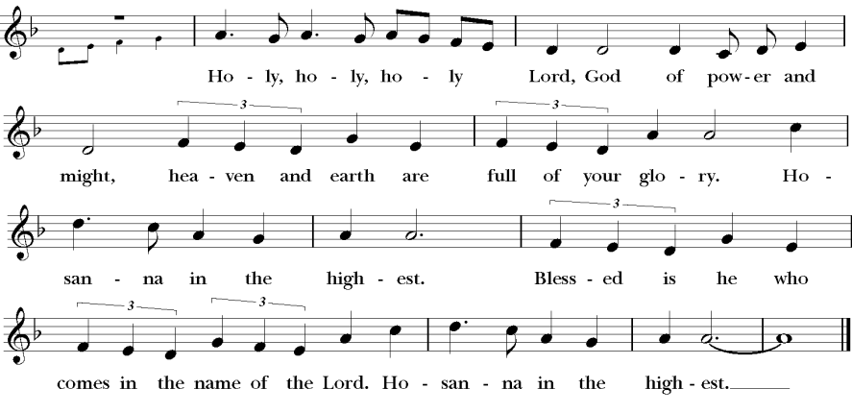

W
The Prayer of Humble Access, said by all, kneeling.
E do not presume to come to this your table, O merciful Lord, trusting in our own righteousness, but in your abundant and great mercies. We are not worthy so much as to gather up the crumbs under your table; but you are the same Lord whose character is always to have mercy. Grant us, therefore, gracious Lord, so to eat the flesh of your dear Son Jesus Christ, and to drink his blood, that our sinful bodies may be made clean by his body, and our souls washed through his most precious blood, and that we may evermore dwell in him, and he in us. Amen.

The People continue to kneel. The minister stands and continues.
A
LL praise and glory is yours, O God our heavenly Father, for in your tender mercy, you gave your only Son Jesus Christ to suffer death upon the Cross for our redemption. He made there, by his one oblation of himself once offered, a full, perfect, and sufficient sacrifice, oblation, and satisfaction, for the sins of the whole world; and he instituted, and in his Holy Gospel commanded us to continue, a perpetual memory of his precious death and sacrifice, until his coming again. Hear us, merciful Father, and grant that we receiving these gifts from your creation, this bread and this wine, according to your Son our Savior Jesus Christ’s institution, in remembrance of his death and passion, may be partakers of his most blessed Body and Blood; For on the night that he was betrayed, our Lord Jesus Christ took bread; and when he had given thanks, he broke it, and gave it to his disciples, saying, “Take, eat; this is my Body, which is given for you: Do this in remembrance of me.” Likewise, after supper, Jesus took the cup, and when he had given thanks, he gave it to them, saying, “Drink this, all of you; for this is my Blood of the New Covenant, which is shed for you, and for many, for the forgiveness of sins: Whenever you drink it, do this in remembrance of me.” AMEN.

Invitation to Communion. All baptized, believing Christians of an understanding age who are admitted to the Sacrament within their own church are encouraged to receive it with us. The New Testament requires some understanding of the Supper, instructing those who commune to ‘discern’ the Body as well as examine themselves before partaking. It is the historic Anglican practice for young children to be catechized before receiving the Supper (feel free to contact a minister for catechism resources). Please come down the middle aisle to receive the bread in open hands and then consume it. Drinking the wine directly from the common cup is the customary manner of receiving it, though the bread may be carefully intincted (dipped) into the wine. Small, individual cups of wine are available in the front for those who have health concerns.
Intercessory prayer is available in the back of the nave in the church. This takes place during the distribution of Communion. You can come back for prayer for any reason whatsoever. If you want prayer for healing (physical or otherwise), you can also request anointing with oil (a biblical symbol for healing and restoration).

I Heard the Voice of Jesus Say
1 I heard the voice of Jesus say, “Come unto Me and rest;
lay down, thou weary one, lay down thy head upon My breast.”
I came to Jesus as I was, so weary, worn, and sad;
I found in Him a resting place, and He has made me glad.

2 I heard the voice of Jesus say, “Behold, I freely give
the living water, thirsty one; stoop down, and drink, and live.”
I came to Jesus, and I drank of that life-giving stream;
my thirst was quenched, my soul revived, and now I live in Him.

3 I heard the voice of Jesus say, “I am this dark world’s Light;
look unto Me, thy morn shall rise, and all thy day be bright.”
I looked to Jesus, and I found in Him my Star, my Sun;
and in that Light of life I’ll walk, till trav'ling days are done.

He Will Hold Me Fast
1. When I fear my faith will fail Christ will hold me fast
When the tempter would prevail He will hold me fast
I could never keep my hold through life's fearful path
For my love is often cold He must hold me fast

Chorus: He will hold me fast, He will hold me fast
For my Savior loves me so, He will hold me fast

2. Those He saves are His delight Christ will hold me fast
Precious in His holy sight He will hold me fast
He'll not let my soul be lost His promises shall last
Bought by Him at such a cost He will hold me fast

3. For my life He bled and died Christ will hold me fast
Justice has been satisfied He will hold me fast
Raised with Him to endless life He will hold me fast
Till our faith is turned to sight When he comes at last

Christ our Hope in Life and Death
1. What is our hope in life and death? Christ alone, Christ alone
What is our only confidence? That our souls to him belong
Who holds our days within his hand? What comes, apart from his command?
And what will keep us to the end? The love of Christ, in which we stand

Chorus: O sing Alleluia! Our hope springs eternal; O sing Alleluia!
Now and ever we confess:
Christ our hope in life and death

2. What truth can calm the troubled soul? God is good, God is good
Where is his grace and goodness known? In our great Redeemer's blood
Who holds our faith when fears arise? Who stands above the stormy trial?
Who sends the waves that bring us nigh Unto the shore, the rock of Christ? (Chorus)

3. Unto the grave, what will we sing? "Christ, he lives; Christ, he lives!"
And what reward will heaven bring? Everlasting life with him
And we will rise to meet the Lord then sin and death will be destroyed
And we will feast in endless joy when Christ is ours forevermore (Chorus)

The Lord’s Prayer, said by all
And now, as our Savior Christ has taught us, we are bold to pray,
O
UR Father, Who art in heaven, hallowed be thy Name, thy kingdom come, thy will be done, on earth as it is in heaven. Give us this day our daily bread. And forgive us our trespasses, as we forgive those who trespass against us. And lead us not into temptation, but deliver us from evil. For Thine is the kingdom, and the power, and the glory, forever and ever. Amen.

A
Post-Communion Prayer, said by all
LMIGHTY and ever-living God, we thank you for feeding us, in these holy mysteries, with the spiritual food of the most precious Body and Blood of your Son our Savior Jesus Christ; and for assuring us, through this Sacrament, of your favor and goodness towards us: that we are true members of the mystical body of your Son, the blessed company of all faithful people; and are also heirs, through hope, of your everlasting kingdom. And we humbly ask you, heavenly Father, to assist us with your grace, that we may continue in that holy fellowship, and do all the good works that you have prepared for us to walk in; through Jesus Christ our Lord, to whom, with you and the Holy Spirit, be all honor and glory, now and for ever. Amen.

Gloria in Excelsis
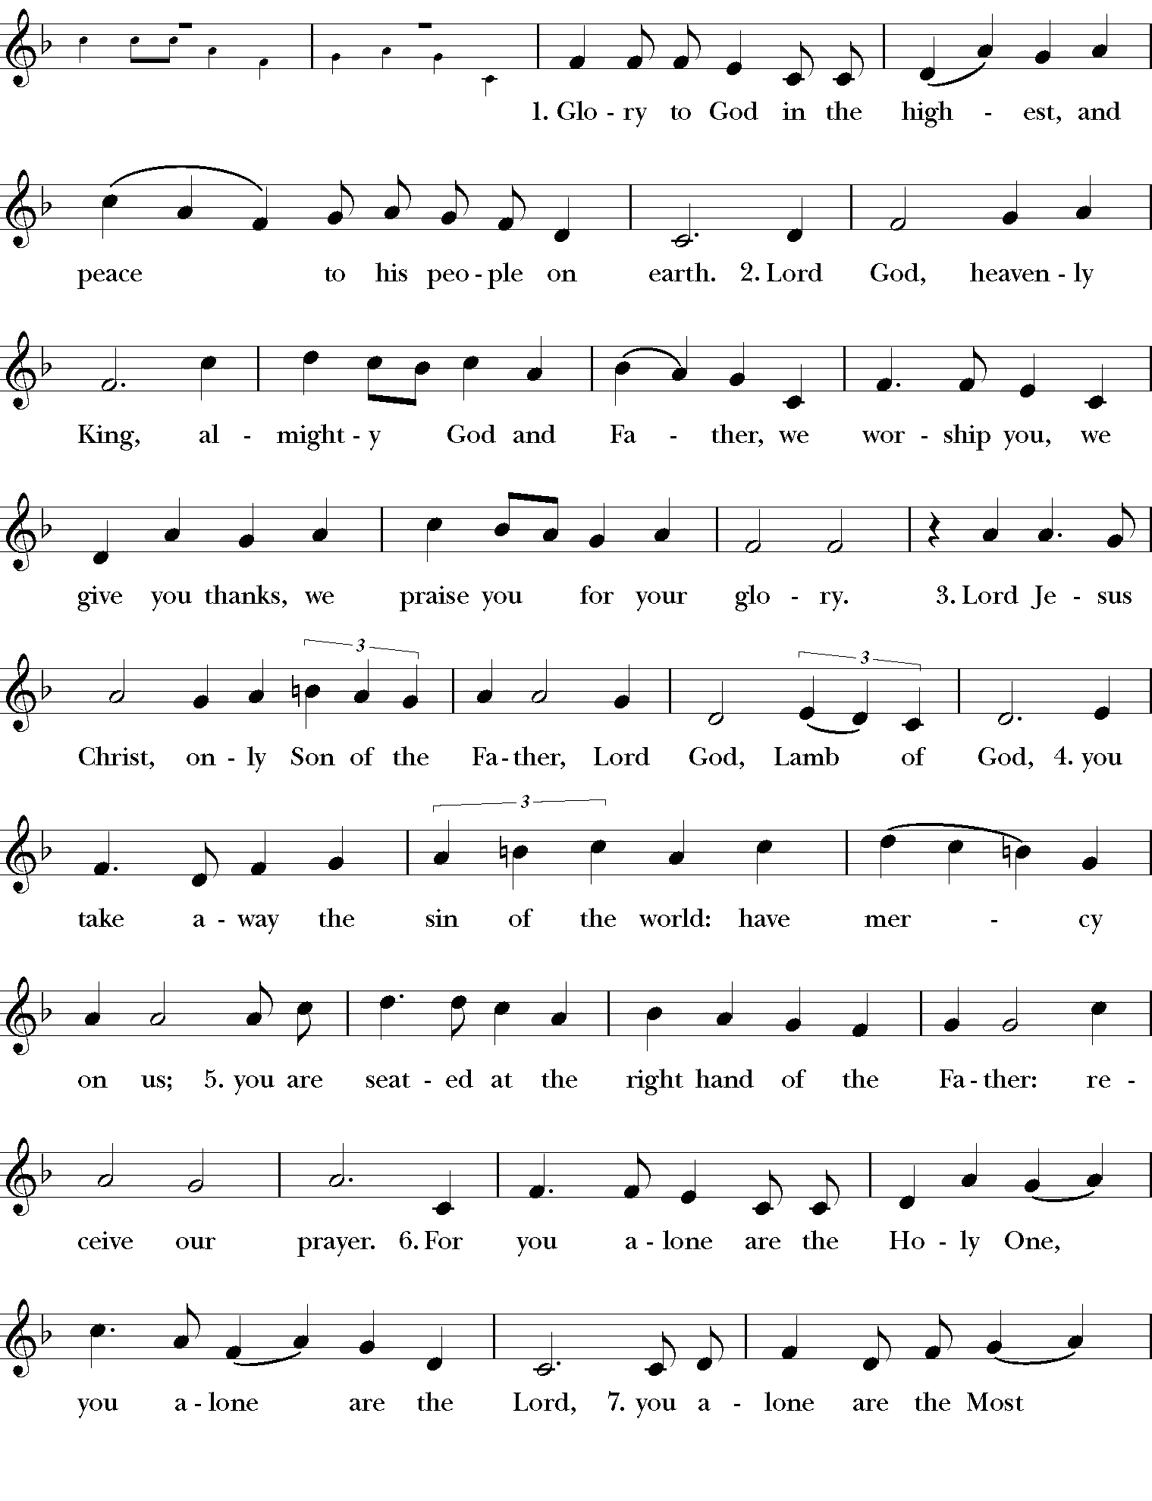
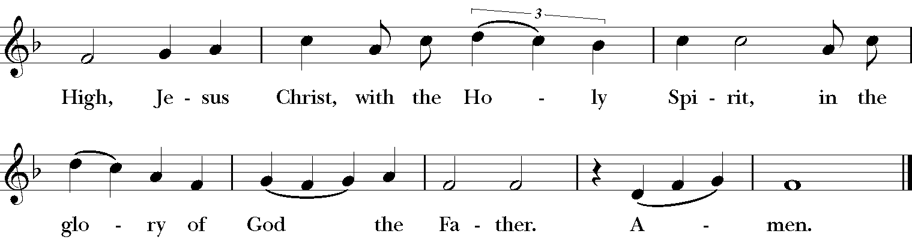

The Epiphany Blessing
M

AY Christ the Son of God perfect in you the image of his glory and gladden your hearts with the good news of his kingdom; and the blessing of God Almighty: the Father, the Son, and the Holy Spirit, be upon you and remain with you forever. Amen.

Recessional Hymn: I Love to Tell the Story Words: Hankey, 1866 Tune: Joyful Songs

1. I love to tell the story of unseen things above,
of Jesus and his glory, of Jesus and his love.
I love to tell the story, because I know 'tis true;
it satisfies my longings as nothing else can do.

Refrain. I love to tell the story, 'twill be my theme in glory,
to tell the old, old story of Jesus and his love.

2. I love to tell the story; tis pleasant to repeat which seems,
each time I tell it, more wonderfully sweet
I love to tell the story, for some have never heard
the message of salvation from God's own holy word

3. I love to tell the story for those who know it best
seem hungering and thirsting to hear it like the rest
and when in scenes of glory I sing the new, new song,
twill be the old, old story that I have loved so long

Go in peace to love and serve the Lord.
Thanks be to God.



GRACE ANGLICAN CHURCH
WHERE GOD’S FREE GRACE ROOTS US, RENEWS US, AND REACHES THROUGH US

ROOTING DOWN – NURTURED & SECURED IN GRACE THROUGH ...
- We serve as a Message-Driven church with PREACHING that clearly exposits the Bible, relentlessly placards the good news of Jesus Christ, and creatively connects the message of redemption to the many crises of the human condition.
- Participating in WORSHIP that is bound to God’s inspired Word, the two Sacraments, the creeds of the ancient Church, the Reformational liturgy of the Book of Common Prayer, and the steadying truths of the 39 Articles of Religion.
- Embracing a biblical, winsome, and counter-cultural ORTHODOXY in matters of faith and ethics.

RESTORING WITHIN – HEALING & GROWING IN GRACE THROUGH ...
- Forging cross-generational, caring RELATIONSHIPS between residents and college students, adults and children.
- Offering OPPORTUNITIES for a deepening relationship with Christ and his church through hospitality, cell groups, prayer, the arts, and recreation.
- TRAINING people of all ages to digest the Scriptures, to pray individually and corporately, and to engage in other life-giving and biblical practices that free us and shape us as disciples of Jesus.

REACHING OUT – EXPRESSING GRACE THROUGH ...
- DISPERSING biblically-equipped, gospel-enriched lay-students and residents, ministers, missionaries, and church planters as compassionate carriers of good news.
- ENGAGING Grove City (both the town and the college) with a warm, imaginative Gospel-witness by creating accessible ‘on ramps’ for those who have yet to encounter Jesus Christ.
- RESOURCING churches in our Diocese and beyond with theological, financial, and personal assets.

GRACE’S STAFF

RECTOR. The Rev’d Ethan Magness is lead-minister at Grace, the principal preacher and teacher, who plans and coordinates worship, leads the staff, offers pastoral care and counsel, marries, buries, etc. (emagness@graceanglicanonline.com)

DIRECTOR OF FAMILY MINISTRIES. Mr. Steve Matson creates, oversees, and develops ministries related to children, youth, and their families; and assists with pastoral care. (smatson@graceanglicanonline.com)

ASSISTANT MINISTER FOR COLLEGE MINISTRY. The Rev’d Cn. Dr Don Shepson has a part-time role with our college students, leads Bible studies, does pastoral care, preaches, etc. (dshepson@graceanglicanonline.com)

PARISH ADMINISTRATOR. Alayna VanKirk serves as our parish administrator, organizing and training volunteers and keeping the parish schedule, prints bulletins, and keeps the parish calendar. (akirk@graceanglicanonline.com)

CELL GROUP OVERSIGHT. The Rev’d Chad Lawrence helps to oversee our cell group ministry, as well as preaches and assists with worship (clawrence@graceanglicanonline.com).

WOMEN’S MINISTRY & HOSPITALITY COORDINATOR. Melissa Cowan leads, oversees, and develops ministries for women, parish hospitality, and new-comer integration.
(mcowan@graceanglicanonline.com)

MUSICIAN. Bethany Mayo coordinates, trains, and rehearses with the music team, and leads our music (bmayo@graceanglicanonline.com)

LIVE-STREAM & AUDIO TECH. Matt Barber runs our live-streaming services. (ink_well2004@yahoo.com)

CHILDREN’S MINISTRY COORDINATOR. Kristen Schools serves part time and helps lead the children’s ministry program and events. kschools@graceanglicanonline.com ).

GRACE’S VESTRY
Ken Smith (Senior Warden) Randy Welker Rob Mueller (Junior Warden)
Emily Jefferis Cindy Marsch (Secretary) Chris Franklin

*Treasurer (non-vestry): Gabe Gordon



