A GOOD FRIDAY LITURGY
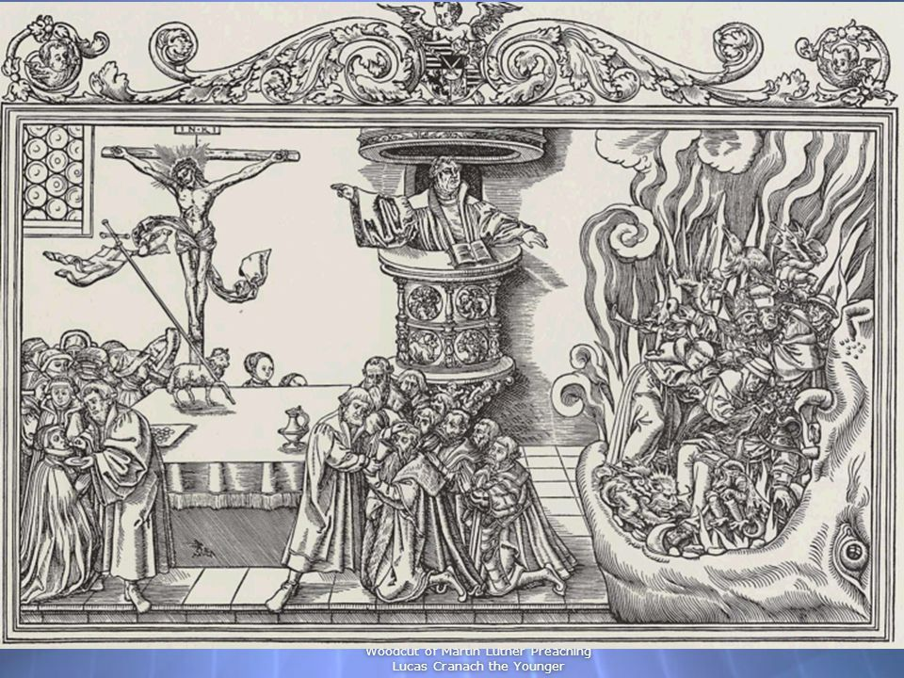

A SHARED SERVICE FOR
HOLY TRINITY LUTHERAN CHURCH
& GRACE ANGLICAN CHURCH

+ + +

April 3, 2026 - 6pm
Announcements

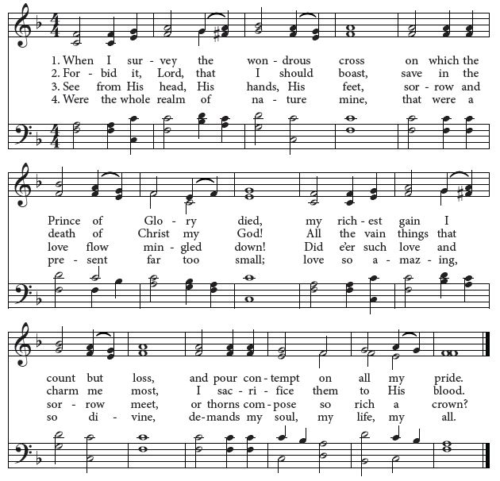 Opening Hymn: When I Survey the Wondrous Cross

4. Were the whole realm of nature mine,
That were an off’ring far too small;
Love so amazing, so divine,
Demands my soul, my life, my all.

Minister Blessed be Christ our God.
People For ever and ever. Amen.
Minister Let us pray.

A
Opening Prayer
LMIGHTY God, we pray you graciously to behold this your family, for whom our Lord Jesus Christ was willing to be betrayed, and given into the hands of sinners, and to suffer death upon the cross; who now lives and reigns with you and the Holy Spirit, one God, for ever and ever. Amen.

The Old Testament Lesson: Isaiah 53:1-6 (ESV)
W

ho has believed our message and to whom has the arm of the Lord been revealed? ² He grew up before him like a tender shoot, and like a root out of dry ground. He had no beauty or majesty to attract us to him, nothing in his appearance that we should desire him. ³ He was despised and rejected by mankind, a man of suffering, and familiar with pain. Like one from whom people hide their faces he was despised, and we held him in low esteem. ⁴ Surely he took up our pain and bore our suffering, yet we considered him punished by God, stricken by him, and afflicted.
⁵ But he was pierced for our transgressions, he was crushed for our iniquities; the punishment that brought us peace was on him, and by his wounds we are healed.
⁶ We all, like sheep, have gone astray, each of us has turned to our own way; and the Lord has laid on him the iniquity of us all.

Reader. Here ends the lesson.

Psalm 69:1-9 (spoken in unison)
1 Save me, O God, *
for the waters have come up even to my neck.
2 I sink down in the deep mire, where there is no ground; *

I have come into deep waters, so that the floods run over me.
3 I am weary of crying; my throat is dry; *
my sight fails me from waiting so long for my God.
4 Those who hate me without a cause are more than the hairs of my head; *
those who are my enemies, and would destroy me wrongfully, are mighty.
5 They bid me restore things I never took. *
O God, you know my foolishness, and my faults are not hidden from you.

6 Let not those who trust in you, O Lord God, be ashamed because of me; *
let not those who seek you be confounded through me, O God of Israel.
7 Surely for your sake have I suffered reproach; *
shame has covered my face.

8 I have become a stranger to my brethren, *
unknown to my mother’s children,
9 Because zeal for your house has consumed me, *
and the reproaches of those who reproached you have fallen upon me.

The Epistle Lesson: Hebrews 10:1-10 (ESV)
S

ince the law has but a shadow of the good things to come instead of the true form of these realities, it can never, by the same sacrifices that are continually offered every year, make perfect those who draw near. ² Otherwise, would they not have ceased to be offered, since the worshipers, having once been cleansed, would no longer have any consciousness of sins? ³ But in these sacrifices there is a reminder of sins every year. ⁴ For it is impossible for the blood of bulls and goats to take away sins. ⁵ Consequently, when Christ came into the world, he said, “Sacrifices and offerings you have not desired, but a body have you prepared for me; ⁶ in burnt offerings and sin offerings you have taken no pleasure. ⁷ Then I said, ‘Behold, I have come to do your will, O God, as it is written of me in the scroll of the book.’”
⁸ When he said above, “You have neither desired nor taken pleasure in sacrifices and offerings and burnt offerings and sin offerings” (these are offered accord-ing to the law), ⁹ then he added, “Behold, I have come to do your will.” He does away with the first in order to establish the second. ¹⁰ And by that will we have been sanctified through the offering of the body of Jesus Christ once for all.

Reader. Here ends the lesson.

Hymn: O Sacred Head, Now Wounded
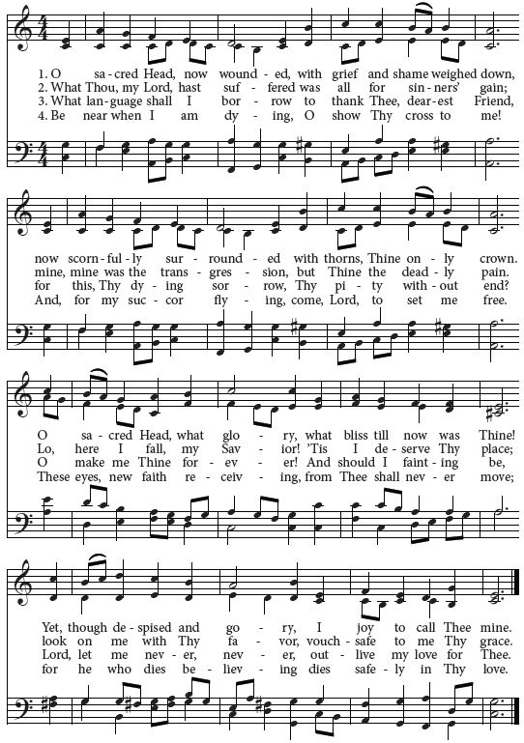

THE BIDDING PRAYERS, all stand
(after the words ‘Almighty and Eternal God’ are read by a minister,
the people join in the remainder of the prayer).

[Please stand]. Let us pray for those preparing for Baptism, that God make them responsive to his love, and give them new life in Jesus Christ. Silent prayer.

Almighty and eternal God, you continually bless the Church with new members. Increase the faith and understanding of those preparing for Baptism. Give them a new birth as your children, and keep them in the faith and communion of your holy Church. We ask this through Christ our Lord. Amen

Let us pray for all our brothers and sisters who share our faith in Jesus Christ, that God may gather and keep together in one Church all those who know Christ as Lord. Silent prayer.

Almighty and eternal God, you give your Church its unity. Look with favor on all who follow Jesus your Son. We are all consecrated to you by our Baptism; make us one in the fullness of faith, and keep us one in the fellowship of love. We ask this through Christ our Lord. Amen

Let us pray for the Jewish people, the first to hear the Word of God, that they may receive the fulfillment of the covenant’s promises. Silent prayer.

Almighty and eternal God, long ago you gave your promise to Abraham and his posterity. Hear the prayers of your Church that the people you first made your own may arrive with us at the fullness of redemption. We ask this through Christ our Lord. Amen

Let us pray for those who do not believe in Christ, that the light of the Holy Spirit may show them the way of salvation. Silent prayer.

Almighty and eternal God, enable those who do not acknowledge Christ to receive the truth of the Gospel. Help us, your people, to grow in love for one another, to grasp more fully the mystery of your Godhead, and so to become more perfect witnesses of your love in the sight of all people. We ask this through Christ our Lord. Amen

Let us pray for those who do not believe in God, that they may find him who is the author and goal of our existence. Silent prayer.

Almighty and eternal God, you created humanity so that all might long to know you and have peace in you. Grant that they may all recognize in the lives of Christians the tokens of your love and mercy, and gladly acknowledge you as the one true God and Father of us all. We ask this through Christ our Lord. Amen

Let us pray for those who serve in public office, that God may guide their minds and hearts, so that all of us may live in true peace and freedom. Silent prayer.

Almighty and eternal God, you are the champion of the poor and oppressed. In your goodness, watch over those in authority, so that people everywhere may enjoy justice, peace, freedom, and a share in the goodness of your creation. We ask this through Christ our Lord. Amen

Let us pray that God, the almighty and merciful Father, may heal the sick, comfort the dying, give safety to travelers, free those unjustly deprived of liberty, and rid the world of falsehood, hunger, and disease. Silent prayer.

Almighty and eternal God, you give strength to the weary and new courage to those who have lost heart. Hear the prayers of all who call on you in any trouble, that they may have the joy of receiving your help in their need. We ask this through Christ our Lord. Amen

Finally, let us pray for all those things for which our Lord would have us ask.
Our Father, who art in heaven, hallowed be thy name, thy kingdom come, thy will be done, on earth as it is in heaven. Give us this day our daily bread; and forgive us our trespasses, as we forgive those who trespass against us; and lead us not into temptation, but deliver us from evil. For thine is the kingdom, and the power, and the glory, forever and ever. Amen

THE REPROACHES

Minister. Recall the wood of the cross; upon it was hung the world’s Salvation.
People. O come, let us adore him.
Minister. ‘O my people, what have I done to you? How have I wearied you?
Testify against me.’ (Micah 6:3).
People: Holy God, holy and mighty, holy Immortal One, have mercy
upon us.

We were liberated from the land of bondage, and set free through the waters of the Red Sea. But the courtroom was prepared for our Savior.

People: Holy God, holy and mighty,
holy Immortal One, have mercy upon us.

Our first-born children were passed-over, and we were led through the wilderness by a pillar of cloud. But the scourging-pillar of Pilate was prepared for our Savior.

People: Holy God, holy and mighty,
holy Immortal One, have mercy upon us.

We were planted as God’s vineyard, to bear the sweetest of fruits and the best of wines. But vinegar was prepared for the Savior.

People: Holy God, holy and mighty,
holy Immortal One, have mercy upon us.

A rock in the desert was struck open and we drank of the water of life. The heavens rained down manna we were spared. But death was prepared for our Savior.

People: Holy God, holy and mighty,
holy Immortal One, have mercy upon us.

THE READING OF THE PASSION – JOHN 19
*The congregation sits for the lesson & verses.

*After each verse of the hymn is sung, a single candle from the candelabra is extinguished.

Reader: The Passion of our Lord Jesus Christ according to John.

P

ilate took Jesus and flogged him. ²And the soldiers twisted together a crown of thorns and put it on his head and arrayed him in a purple robe. ³They came up to him, saying, "Hail, King of the Jews!" and struck him with their hands. ⁴Pilate went out again and said to them, "See, I am bringing him out to you that you may know that I find no guilt in him." ⁵So Jesus came out, wearing the crown of thorns and the purple robe. Pilate said to them, "Behold the man!" ⁶When the chief priests and the officers saw him, they cried out, "Crucify him, crucify him!" Pilate said to them, "Take him yourselves and crucify him, for I find no guilt in him." ⁷The Jews answered him, "We have a law, and according to that law he ought to die because he has made himself the Son of God."

Verse 1.
Ah, holy Jesus, how hast thou offended,
that we to judge thee have in hate pretended?
By foes derided, by thine own rejected,
O most afflicted!

When Pilate heard this statement, he was even more afraid. ⁹He entered his headquarters again and said to Jesus, "Where are you from?" But Jesus gave him no answer. ¹⁰So Pilate said to him, "You will not speak to me? Do you not know that I have authority to release you and authority to crucify you?" ¹¹Jesus answered him, "You would have no authority over me at all unless it had been given you from above. Therefore he who delivered me over to you has the greater sin."

Verse 2.
Who was the guilty? Who brought this upon thee?
Alas, my treason, Jesus, hath undone thee!
‘Twas I, Lord Jesus, I it was denied thee;
I crucified thee.

¹²From then on Pilate tried to release him, but the Jews cried out, ‘If you release this man, you are no friend of the emperor. Everyone who claims to be a king sets himself against the emperor.’ ¹³ When Pilate heard these words, he brought Jesus outside and sat on the judge’s bench at a place called The Stone Pavement, or in Hebrew Gabbatha. ¹⁴ Now it was the day of Preparation for the Passover; and it was about noon. He said to the Jews, ‘Here is your King!’ ¹⁵ They cried out, ‘Away with him! Away with him! Crucify him!’ Pilate asked them, ‘Shall I crucify your King?’ The chief priests answered, ‘We have no king but the emperor.’ ¹⁶ Then he handed him over to them to be crucified.

Verse 3.
Lo, the Good Shepherd for the sheep is offered;
the slave hath sinn-ed, and the Son hath suffered.
For our atonement, while we nothing heeded,
God interceded

So they took Jesus, ¹⁷and he went out, bearing his own cross, to the place called the place of a skull, which in Aramaic is called Golgotha. ¹⁸There they crucified him, and with him two others, one on either side, and Jesus between them. ¹⁹Pilate also wrote an inscription and put it on the cross. It read, "Jesus of Nazareth, the King of the Jews." ²⁰Many of the Jews read this inscription, for the place where Jesus was crucified was near the city, and it was written in Aramaic, in Latin, and in Greek. ²¹So the chief priests of the Jews said to Pilate, "Do not write, 'The King of the Jews,' but rather, 'This man said, I am King of the Jews.'" ²²Pilate answered, "What I have written I have written."

Verse 4.
For me, kind Jesus, was thy incarnation,
thy mortal sorrow, and thy life’s oblation,
thy death of anguish and thy bitter passion,
for my salvation.

²³When the soldiers had crucified Jesus, they took his garments and divided them into four parts, one part for each soldier; also his tunic. But the tunic was seamless, woven in one piece from top to bottom, ²⁴so they said to one another, "Let us not tear it, but cast lots for it to see whose it shall be." This was to fulfill the Scripture which says, "They divided my garments among them, and for my clothing they cast lots."

Verse 5.
Thy pure-sown body, like the seed, has fallen,
into the darkness, buried and forgotten,
planted, entomb-ed, lying still and waiting
Dead, yet e’re saving.

So the soldiers did these things, ²⁵but standing by the cross of Jesus were his mother and his mother's sister, Mary the wife of Clopas, and Mary Magdalene. ²⁶When Jesus saw his mother and the disciple whom he loved standing nearby, he said to his mother, "Woman, behold, your son!" ²⁷Then he said to the disciple, "Behold, your mother!" And from that hour the disciple took her to his own home. ²⁸After this, Jesus, knowing that all was now finished, said (to fulfill the Scripture), "I thirst." ²⁹A jar full of sour wine stood there, so they put a sponge full of the sour wine on a hyssop branch and held it to his mouth. ³⁰When Jesus had received the sour wine, he said, "It is finished," and he bowed his head and gave up his spirit.

Verse 6.
Therefore, kind Jesus, since I cannot pay thee,
I do adore thee, and will ever pray thee,
think on thy pity and thy love unswerving,
not my deserving.

Since it was the day of Preparation, and so that the bodies would not remain on the cross on the Sabbath (for that Sabbath was a high day), the Jews asked Pilate that their legs might be broken and that they might be taken away. ³²So the soldiers came and broke the legs of the first, and of the other who had been crucified with him. ³³But when they came to Jesus and saw that he was already dead, they did not break his legs. ³⁴But one of the soldiers pierced his side with a spear, and at once there came out blood and water. ³⁵He who saw it has borne witness--his testimony is true, and he knows that he is telling the truth--that you also may believe. ³⁶For these things took place that the Scripture might be fulfilled: "Not one of his bones will be broken." ³⁷And again another Scripture says, "They will look on him whom they have pierced."

Silence is kept.

L
Concluding Prayer

ORD Jesus Christ, Son of the living God, we ask you to set your passion, cross, and death between your judgment and our souls, now and in the hour of our death. Give mercy to the living, to your holy Church peace and concord, and to us sinners everlasting life and glory; for with the Father and the Holy Spirit you live and reign, now and forever. Amen.
The church lights go out, silence is kept.

* Those who wish to write sins from which they wish to repent on the paper included in the bulletin may walk toward the cross and place that same paper on one of the nails during the singing of “Jesus, Remember Me.” No one will read them. We burn these papers at the beginning of our Vigil Service on Holy Saturday.

Hymn of Reflection: Jesus, Remember Me (from Taize)
*Repeated several times as a meditative piece
