THE GREAT VIGIL
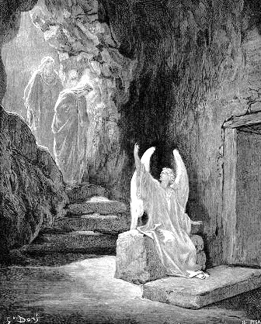
OF EASTER

NOTES.

Candles. Please be extra careful with your lit candles, and especially with candles held by children, as they are lit for a very long time during tonight’s service (that is, until the Easter Acclamation on page 19). Candles represent the unconquerable light of Christ that always outlasts and outshines the darkness.

Bells. During the Easter Acclamation and during the ‘Alleluias’ in our hymns, ring your bells like a mad-man/woman. Tonight, we celebrate – with the glad-ringing of bells – the death of death.

*When the service is over please place the bells in the baskets near the entrances.

Thank you to Bethany Mayo, Sarah Mitchell (choir master), Johnny Adkins (cellist), our accompanying musicians, our live-stream crew, and to all those who helped make this service a success. We are supremely grateful for your efforts tonight!

Choir Members:
Sopranos: Kaitlyn Bennett, Genevieve James
Cora Magness

Altos: Margaret Herbener, Sarah Mitchell
Alex Franz

Tenors: Steve Matson, Rob Mueller

Bass: Matt James, Will Mueller

Tomorrow is Easter! Please join us 8:30am.
***NO evening service tomorrow.
THE GREAT VIGIL OF EASTER

In the darkness, fire is kindled; after which the minister says
D
EAR friends in Christ: On this most holy night, in which our Lord Jesus passed over from death to life, the Church invites her members, dispersed throughout the world, to gather in vigil and prayer. For this is the Passover of the Lord, in which, by hearing his Word, we share in his victory over death.

M

AY the light of Christ, rising in glory, banish all darkness from our hearts and minds.

When all are assembled in the nave, and the clergy and servers process, the minister lights the candles from the Paschal candle, and pausing three times during the procession, sings,

Officiant People
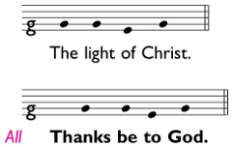

The light of Christ. Thanks be to God.

Candles are lit from the Paschal candle except for those on the Table. The Paschal candle is then placed in its stand.

The people continue stand through the Exsultet.

R
THE EXSULTET
EJOICE now, heavenly hosts and choirs of angels,
and let your trumpets shout Salvation
for the victory of our mighty King.

Rejoice and sing now, all the round earth,
bright with a glorious splendor,
for darkness has been vanquished by our eternal King.

Rejoice and be glad now, Mother Church,
and let your holy courts, in radiant light,
resound with the praises of your people.

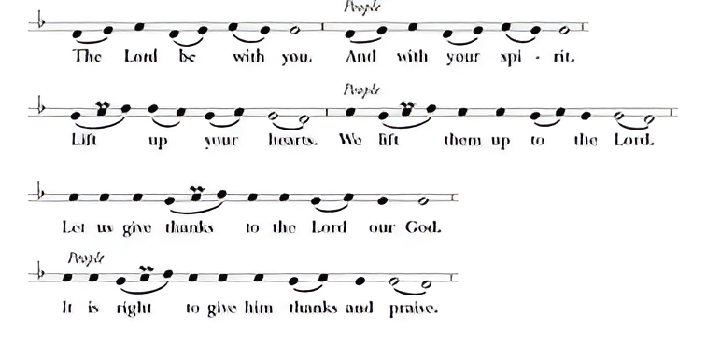
I

T is truly right and good, always and everywhere,
with our whole heart and mind and voice,
to praise you, the invisible, almighty, and eternal God,
and your only-begotten Son, Jesus Christ our Lord;
for he is the true Paschal Lamb,
who at the feast of the Passover paid for us the debt of Adam's sin,
and by his blood delivered your faithful people.

This is the night, when you brought our fathers,
the children of Israel, out of bondage in Egypt,
and led them through the Red Sea on dry land.

This is the night, when all who believe in Christ
are delivered from the gloom of sin,
and are restored to grace and holiness of life.

This is the night, when Christ broke the bonds of death and hell,
and rose victorious from the grave.

How wonderful and beyond our knowing, O God,
is your mercy and loving-kindness to us,
that to redeem a slave, you gave a Son.

How holy is this night
when wickedness is put to flight and sin is washed away.
It restores innocence to the fallen, and joy to those who mourn.
It casts out pride and hatred, and brings peace and concord.

How blessed is this night,
when earth and heaven are joined and man is reconciled to God.

Holy Father, accept our evening sacrifice of praise;
May Christ, the Morning Star who knows no setting,
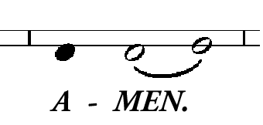
give his light to all creation,
who lives and reigns for ever and ever.
L
The Lessons
ET us hear the record of God’s saving deeds in history, remembering how he saved his people in ages past and in the fullness of time sent his Son to be our Redeemer; and let us pray that God may bring to completion in each of us the saving work he has begun.

THE BEGINNING

The First Lesson: Genesis 1:1-2:3.

Reader. A reading from the Book of Genesis.

I
n the beginning, God created the heavens and the earth. ² The earth was without form and void, and darkness was over the face of the deep. And the Spirit of God was hovering over the face of the waters. ³ And God said, “Let there be light,” and there was light. ⁴ And God saw that the light was good. And God separated the light from the darkness.⁵ God called the light Day, and the darkness he called Night. And there was evening and there was morning, the first day.
⁶ And God said, “Let there be an expanse in the midst of the waters, and let it separate the waters from the waters.” ⁷ And God made the expanse and separated the waters that were under the expanse from the waters that were above the expanse. And it was so. ⁸ And God called the expanse Heaven. And there was evening and there was morning, the second day.
⁹ And God said, “Let the waters under the heavens be gathered together into one place, and let the dry land appear.” And it was so. ¹⁰ God called the dry land Earth, and the waters that were gathered together he called Seas. And God saw that it was good.
¹¹ And God said, “Let the earth sprout vegetation, plants yielding seed, and fruit trees bearing fruit in which is their seed, each according to its kind, on the earth.” And it was so. ¹² The earth brought forth vegetation, plants yielding seed according to their own kinds, and trees bearing fruit in which is their seed, each according to its kind. And God saw that it was good. ¹³ And there was evening and there was morning, the third day.
¹⁴ And God said, “Let there be lights in the expanse of the heavens to separate the day from the night. And let them be for signs and for seasons, and for days and years, ¹⁵ and let them be lights in the expanse of the heavens to give light upon the earth.” And it was so.¹⁶ And God made the two great lights—the greater light to rule the day and the lesser light to rule the night—and the stars. ¹⁷ And God set them in the expanse of the heavens to give light on the earth, ¹⁸ to rule over the day and over the night, and to separate the light from the darkness. And God saw that it was good. ¹⁹ And there was evening and there was morning, the fourth day.
²⁰ And God said, “Let the waters swarm with swarms of living creatures, and let birds fly above the earth across the expanse of the heavens.”²¹ So God created the great sea creatures and every living creature that moves, with which the waters swarm, according to their kinds, and every winged bird according to its kind. And God saw that it was good. ²² And God blessed them, saying, “Be fruitful and multiply and fill the waters in the seas, and let birds multiply on the earth.” ²³ And there was evening and there was morning, the fifth day.
²⁴ And God said, “Let the earth bring forth living creatures according to their kinds—livestock and creeping things and beasts of the earth according to their kinds.” And it was so. ²⁵ And God made the beasts of the earth according to their kinds and the live-stock according to their kinds, and everything that creeps on the ground according to its kind. And God saw that it was good.
²⁶ Then God said, “Let us make man in our image, after our likeness. And let them have dominion over the fish of the sea and over the birds of the heavens and over the livestock and over all the earth and over every creeping thing that creeps on the earth.” ²⁷ So God created man in his own image, in the image of God he created him;
male and female he created them.
²⁸ And God blessed them. And God said to them, “Be fruitful and multiply and fill the earth and subdue it, and have dominion over the fish of the sea and over the birds of the heavens and over every living thing that moves on the earth.” ²⁹ And God said, “Behold, I have given you every plant yielding seed that is on the face of all the earth, and every tree with seed in its fruit. You shall have them for food. ³⁰ And to every beast of the earth and to every bird of the heavens and to everything that creeps on the earth, everything that has the breath of life, I have given every green plant for food.” And it was so. ³¹ And God saw every-thing that he had made, and behold, it was very good. And there was evening and there was morning, the sixth day.

2 Thus the heavens and the earth were finished, and all the host of them. ² And on the seventh day God finished his work that he had done, and he rested on the seventh day from all his work that he had done.³ So God blessed the seventh day and made it holy, because on it God rested from all his work that he had done in creation.

CHOIR - The Spacious Firmament by Franz Joseph Haydn

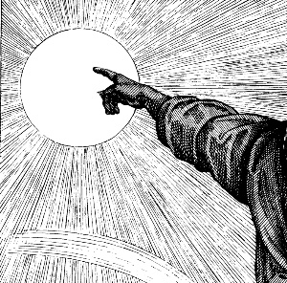
Let us pray. (Silence)

O God, who wonderfully created, and yet more wonderfully restored, the dignity of human nature: Grant that we may share the divine life of him who humbled himself to share our humanity, your Son Jesus Christ our Lord. Amen.

THE REVOLT

The Second Lesson: Genesis 3:1-15.

Reader. A reading from the Book of Genesis.

T
he serpent was more crafty than any other beast of the field that the Lord God had made. He said to the woman, “Did God actually say, ‘You shall not eat of any tree in the garden’?” ² And the woman said to the serpent, “We may eat of the fruit of the trees in the garden, ³ but God said, ‘You shall not eat of the fruit of the tree that is in the midst of the garden, neither shall you touch it, lest you die.’” ⁴ But the serpent said to the woman, “You will not surely die. ⁵ For God knows that when you eat of it your eyes will be opened, and you will be like God, knowing good and evil.” ⁶ So when the woman saw that the tree was good for food, and that it was a delight to the eyes, and that the tree was to be desired to make one wise, she took of its fruit and ate, and she also gave some to her husband who was with her, and he ate. ⁷ Then the eyes of both were opened, and they knew that they were naked. And they sewed fig leaves together and made themselves loin-cloths. ⁸ And they heard the sound of the Lord God walking in the garden in the wind of the day, and the man and his wife hid themselves from the presence of the Lord God among the trees of the garden. ⁹ But the Lord God called to the man and said to him, “Where are you?” ¹⁰ And he said, “I heard the sound of you in the garden, and I was afraid, because I was naked, and I hid myself.” ¹¹ He said, “Who told you that you were naked? Have you eaten of the tree of which I commanded you not to eat?” ¹² The man said, “The woman whom you gave to be with me, she gave me fruit of the tree, and I ate.” ¹³ Then the Lord God said to the woman, “What is this that you have done?” The woman said, “The serpent deceived me, and I ate.”
¹⁴ The Lord God said to the serpent, “Because you have done this,
cursed are you above all livestock and above all beasts of the field; on your belly you shall go, and dust you shall eat all the days of your life. ¹⁵ I will put enmity between you and the woman, and between your offspring and her offspring; he shall crush your head,
and you shall bruise his heel.”

ANOINTING THE SICK – by Bryce Lowe

You bear this pain,
Now bear his name
In oil on your head.
Now marked as his,
Receive this kiss
From Christ who loves the dead.
Your body fails,
His body failed
When on your cross he bled.
All flesh will die,
So with him lie
Upon his stony bed,
That as he lives
So you may live
With blood both warm and red

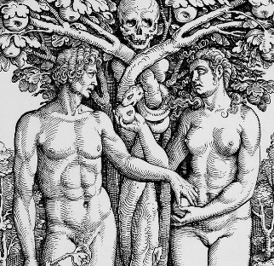
Let us pray. (Silence)

O God, you sent your blessed Son, the seed of the woman, that he might crush the serpent’s head and make all creation new: Grant that, having this hope, we may purify ourselves as he is pure; that, when he comes again with power and great glory, we may be made like him in his eternal and glorious kingdom; through Jesus Christ our Lord. Amen.
THE DELUGE

The Third Lesson: Genesis 7:1-2, 11-14; 8:13-14, 9:8-13

Reader. A reading from the Book of Genesis.

T

he Lord said to Noah, “Go into the ark, you and all your house-hold, for I have seen that you are right-eous before me in this generation. ² Take with you seven pairs of all clean animals, the male and his mate, and a pair of the animals that are not clean, the male and his mate.

And the fountains of the great deep burst forth, and the windows of the heavens were opened. ¹² And rain fell upon the earth forty days and forty nights. ¹³ On the very same day Noah and his sons, Shem and Ham and Japheth, and Noah's wife and the three wives of his sons with them entered the ark, ¹⁴ they and every beast, according to its kind.

In the six hundred and first year, in the first month, the first day of the month, the waters were dried from off the earth. And Noah removed the covering of the ark and looked, and behold, the face of the ground was dry. ¹⁴ In the second month, on the twenty-seventh day of the month, the earth had dried out.

Then God said to Noah and to his sons with him, ⁹ “I establish my covenant with you, that never again shall all flesh be cut off by the waters of the flood, and never again shall there be a flood to destroy the earth.” ¹² And God said, “This is the sign of the covenant that I make between me and you and every living creature that is with you, for all future generations: ¹³ I have set my bow in the cloud, and it shall be a sign of the covenant between me and the earth.”

Instrumental Duet: Elegy by Pierre Manchot

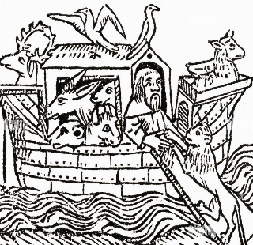
Let us pray. (Silence)

Grant, Lord, that we who are baptized into the death of your Son our Savior Jesus Christ may continually put to death our evil desires and be buried with him; and that through the grave and gate of death we may pass to our joyful resurrect-ion; through the merits of him who died and was buried and rose again for us, your Son Jesus Christ our Lord. Amen.
THE BINDING OF ISAAC

The Third Lesson: Genesis 22:1-14.

Reader. A reading from the Book of Genesis.

G

od tested Abraham and said to him, “Abraham!” And he said, “Here I am.” ² He said, “Take your son, your only son Isaac, whom you love, and go to the land of Moriah, and offer him there as a burnt offering on one of the mountains of which I shall tell you.” ³ So Abraham rose early in the morning, saddled his donkey, and took two of his young men with him, and his son Isaac. And he cut the wood for the burnt offering and arose and went to the place of which God had told him. ⁴ On the third day Abraham lifted up his eyes and saw the place from afar. ⁵ Then Abraham said to his young men, “Stay here with the donkey; I and the boy will go over there and worship and come again to you.” ⁶ And Abraham took the wood of the burnt offering and laid it on Isaac his son. And he took in his hand the fire and the knife. So they went both of them together. ⁷ And Isaac said to his father Abraham, “My father!” And he said, “Here I am, my son.” He said, “Behold, the fire and the wood, but where is the lamb for a burnt offering?” ⁸ Abraham said, “God will provide for himself the lamb for a burnt offering, my son.” So they went both of them together.
⁹ When they came to the place of which God had told him, Abraham built the altar there and laid the wood in order and bound Isaac his son and laid him on the altar, on top of the wood. ¹⁰ Then Abraham reached out his hand and took the knife to slaughter his son. ¹¹ But the angel of the Lord called to him from heaven and said, “Abraham, Abraham!” And he said, “Here I am.” ¹² He said, “Do not lay your hand on the boy or do anything to him, for now I know that you fear God, seeing you have not withheld your son, your only son, from me.” ¹³ And Abraham lifted up his eyes and looked, and behold, behind him was a ram, caught in a thicket by his horns. And Abraham went and took the ram and offered it up as a burnt offering instead of his son. ¹⁴ So Abraham called the name of that place, “The Lord will provide”; as it is said to this day, “On the mount of the Lord it shall be provided.”

SARAH – by Cindy Marsch

Her gnarled hand clenched the folds of the tent curtain, her nails digging into her palm as she willed herself—“Be still.”
Burning eyes—dry after many tears—peered through the shadows to discern them setting out against the dark.
“I am called,” he had said. As always, that meant she, too, was called. Forever they had wandered—their tents bundled with them—nothing settled, not even a child to set their hopes upon. Always it was “yet further” and “not yet.” Once he bade her hide in a harem. What good could come of that? And once she bade him take her maid. No good had come of that!
She scoffed—a bitter bark of a laugh—her lip curled, eyes turned away.
He—bewildered old man—turned eyes of helpless apology toward her—empty hands below the blank sky.
So long, so far. They dried up and slowed as life-hope swept into the desert winds swirling around them.
Then came visitors—so they stirred their creaky bones to greet them, to refresh them, to listen. She had gripped the curtain then, too, her knees weakened at the ridiculous words. Had she laughed? They said so, though it would have been a croak—a crone’s cackle. Still, some tiny hope had bidden tears from her dry eyes, and her nose had run, and the next laugh dropped her to her knees.
Some hidden spring coursed life through her body, and when the visitors left, she fell into weary sleep. She awoke refreshed, curled around him, their fingers entwined in their dreams. Rosy dawn pressed against the tent curtain, and there began a new day.
Both of them laughed, then, as life returned to them, and as the flutter within her made every day more certain. The call was at last having its answer in their very bodies—in hers.
All the camp whispered, and gasped, then laughed with them, too, in what should not have been but here WAS! And so his name—"laughter.”
Their own son could have been their grandson’s child, but the One who withheld so much so long had made it so. And thus her husband could recall the words of stars and grains of sand. The One could do that, too.
So the boy grew, their delight, her joy. She counted the years until he would father a multitude, for surely he’d need many sons and daughters in his turn. More tents, if tents it must be, but perhaps a town . . .
Then came another call, all in a hurry of days to depart. The old man’s eyes glittered with fear that clutched at her heart. Wild sorrow!
What now? Would this caprice finally take her down to the depths of the earth, in groaning, dry, hollow cries, her bones crumbled to dust?
Was this the cruel end, her boy led away like a fresh maiden adorned and led to the burning altar? A fit sacrifice, most beautiful of all their people had, thrown into the maw of the ravening god? Was this what this One required? She had seen this lament in the old man’s eyes.
She had no tears, no strength now. Nothing left, truly. But still, her dry, gritty eyes strained to see.
And there, in the depth of dark sky above dark hills beyond the dark tent—a point of light—the morning star.

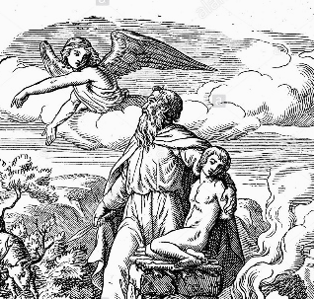
Let us pray. (Silence)

Almighty God, whose servant Abraham faithfully obeyed your call, and rejoiced to see the day of your Son: multiply the number of your children by the grace of the Lamb who was slain; that your Church may also rejoice to see your promise to our father Abraham fulfilled; through Jesus Christ our Lord. Amen.
THE EMANCIPATION

The Fourth Lesson: Exodus 14:21-15:1.

Reader. A reading from the Book of Exodus.

M

oses stretched out his hand over the sea, and the Lord drove the sea back by a strong east wind all night and made the sea dry land, and the waters were divided. ²² And the people of Israel went into the midst of the sea on dry ground, the waters being a wall to them on their right hand and on their left. ²³ The Egyptians pursued and went in after them into the midst of the sea, all Pharaoh's horses, his chariots, and his horsemen. ²⁴ And in the morning watch the Lord in the pillar of fire and of cloud looked down on the Egyptian forces and threw the Egyptian forces into a panic, ²⁵ clog-ging their chariot wheels so that they drove heavily. And the Egyptians said, “Let us flee from before Israel, for the Lord fights for them against the Egyptians.”
²⁶ Then the Lord said to Moses, “Stretch out your hand over the sea, that the water may come back upon the Egyptians, upon their chariots, and upon their horsemen.” ²⁷ So Moses stretched out his hand over the sea, and the sea returned to its normal course when the morning appeared. And as the Egyptians fled into it, the Lord threw the Egyptians into the midst of the sea.
²⁸ The waters returned and covered the chariots and the horsemen; of all the host of Pharaoh that had followed them into the sea, not one of them remained. ²⁹ But the people of Israel walked on dry ground through the sea, the waters being a wall to them on their right hand and on their left.
³⁰ Thus the Lord saved Israel that day from the hand of the Egyptians, and Israel saw the Egyptians dead on the seashore. ³¹ Israel saw the great power that the Lord used against the Egyptians, so the people feared the Lord, and they
believed in the Lord and in his servant Moses.

15 Then Moses and the people of Israel sang this song to the Lord, saying, “I will sing to the Lord, for he has triumphed gloriously; the horse and his rider he has thrown into the sea.”

CHOIR - Hark! A Thrilling Voice is Sounding by William H. Monk

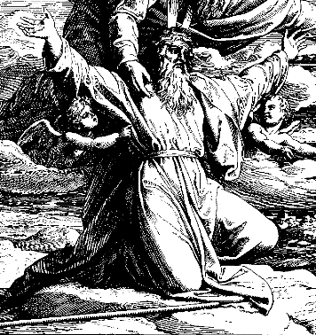
Let us pray. (Silence)

O God, whose wonderful deeds of old shine forth even to our own day, by the power of your mighty arm you once delivered your chosen people from slavery under Pharaoh, to be a sign for us of the salvation offered to all nations by the water of Baptism: Grant that all the peoples of the earth may be numbered among the offspring of Abraham, and rejoice in the inheritance of Israel; through Jesus Christ our Lord. Amen.
THE INDWELLING SPIRIT

The Fifth Lesson: Ezekiel 36:24-28.

Reader. A reading from the Prophet Ezekiel.

I
will take you from the nations and gather you from all the countries and bring you into your own land.
²⁵ I will sprinkle clean water on you, and you shall be clean from all your unclean-nesses, and from all your idols I will cleanse you. ²⁶ And I will give you a new heart, and a new spirit I will put within you. And I will remove the heart of stone from your flesh and give you a heart of flesh. ²⁷ And I will put my Spirit within you, and cause you to walk in my statutes and be careful to obey my rules. ²⁸ You shall dwell in the land that I gave to your fathers, and you shall be my people, and I will be your God.

STAINED GLASS CHRIST – Ross Kucks

The leaden cold plummets the sky,
Incessant snow cloaks a shadowed gloaming,
The firs’ shoulders sag under wet ice,
And the frozen blanket of light deadens all.

The church is an ember between cold walls
Pinioned beneath three black windows –
Glass veined with lead and carrying
A coal dark Christ, surrounded by shadows,
Burdened with the work of infusing beauty out of light
To lighten a cavern of huddled coats
And point eyes of longing toward eternal summer.

Not now, though, under grey skies –
Only an ash black king stands undiscernible above.

But hearts beget what eyes cannot behold
Fill lines with light to trace the hidden scene;
Upon the empty slate affixed above
Decants a sunshine night cannot remove.

Though desiccated boughs are flayed by storm
And ice shrouds earth in deadly solitude
The frozen glass and lead are strangely warmed
As worshippers adorn the window’s gloom
With holy fire - the shepherd’s face emerges
From the tomb.

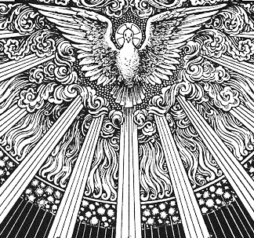
Let us pray. (Silence)

Heavenly Father, by the power of your Holy Spirit you promise your faithful people new life in the water of baptism: Guide and strengthen us by the same Spirit, that we who are born again may serve you in faith and love, and grow into the full stature of your Son Jesus Christ our Lord. Amen.
THE GREAT FISH

The Seventh Lesson: Jonah 1:11-2:10.

Reader. A reading from the Prophet Jonah.
T

he sailors said to Jonah], “What shall we do to you, that the sea may quiet down for us?” For the sea grew more and more tempestuous. ¹² He said to them, “Pick me up and hurl me into the sea; then the sea will quiet down for you, for I know it is because of me that this great tempest has come upon you.” ¹³ Nevertheless, the men rowed hard to get back to dry land, but they could not, for the sea grew more and more tempestuous against them. ¹⁴ Therefore they called out to the Lord, “O Lord, let us not perish for this man's life, and lay not on us innocent blood, for you, O Lord, have done as it pleased you.” ¹⁵ So they picked up Jonah and hurled him into the sea, and the sea ceased from its raging. ¹⁶ Then the men feared the Lord exceedingly, and they offered a sacrifice to the Lord and made vows.
¹⁷And the Lord appointed a great fish to swallow up Jonah. And Jonah was in the belly of the fish three days and three nights.
2 Then Jonah prayed to the Lord his God from the belly of the fish, ² saying, “I called out to the Lord, out of my distress, and he answered me; out of the belly of Sheol I cried, and you heard my voice. ³ For you cast me into the deep, into the heart of the seas, and the flood surrounded me; all your waves and your billows passed over me. ⁴ Then I said, ‘I am driven away from your sight; yet I shall again look upon your holy temple.’ ⁵ The waters closed in over me to take my life; the deep surrounded me; weeds were wrapped about my head ⁶ at the roots of the mountains. I went down to the land whose bars closed upon me forever; yet you brought up my life from the pit, O Lord my God. ⁷ When my life was fainting away, I remembered the Lord, and my prayer came to you, into your holy temple. ⁸ Those who pay regard to vain idols forsake their hope of steadfast love. ⁹ But I with the voice of thanksgiving will sacrifice to you; what I have vowed I will pay. Salvation belongs to the Lord!”
¹⁰ And the Lord spoke to the fish, and it vomited Jonah out upon the dry land.

Instrumental Duet: The Moonlight by Beethoven.

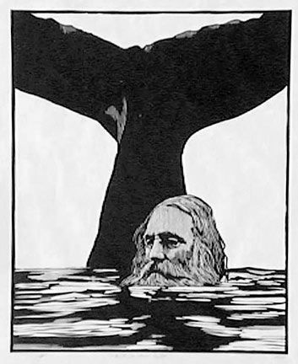
Let us pray. (Silence)

Almighty God, by the Resurrection of your Son you have brought us out of sin into righteousness and out of death into life: Grant to those who are sealed by your Holy Spirit the will and the power to proclaim you to all the world; through Jesus Christ our Lord. Amen.
THE INGATHERING

The Eighth Lesson: Zephaniah 3:14-20.

Reader. A reading from the Prophet Zephaniah.
S

ing aloud, O daughter of Zion; shout, O Israel! Rejoice and exult with all your heart, O daughter of Jerusalem! ¹⁵ The Lord has taken away the judgments against you; he has cleared away your enemies. The King of Israel, the Lord, is in your midst; you shall never again fear evil. ¹⁶ On that day it shall be said to Jerusalem: “Fear not, O Zion; let not your hands grow weak. ¹⁷ The Lord your God is in your midst, a mighty one who will save; he will rejoice over you with gladness; he will quiet you by his love; he will exult over you with loud sing-ing. ¹⁸ I will gather those of you who mourn for the festival, so that you will no longer suffer reproach. ¹⁹ Behold, at that time I will deal with all your oppressors. And I will save the lame and gather the outcast, and I will change their shame into praise and renown in all the earth. ²⁰ At that time I will bring you in, at the time when I gather you together; for I will make you renowned and praised among all the peoples of the earth, when I restore your fortunes before your eyes,” says the Lord.

CHOIR - Of the Father's Love Begotten by Aurelius Clemens Prudentius, 13th Cen Finnish Plainsong

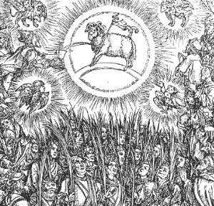
Let us pray. (Silence)

Almighty God, you called your Church to bear witness that you were in Christ reconciling the world to yourself: give us boldness to proclaim the good news of your love, that all who hear it may be drawn to you; through him who was lifted high upon the cross, Jesus Christ our Lord. Amen.
THE SACRAMENT OF HOLY BAPTISM
D
EARLY BELOVED, Scripture teaches that we were all dead in our sins and trespasses, but by grace we may be saved through faith. Our Savior Jesus Christ said, “Unless one is born of water and the Spirit, he cannot enter the kingdom of God”; and he commissioned the Church to “make disciples of all nations, baptizing them in the Name of the Father, and of the Son, and of the Holy Spirit.” Here we ask our heavenly Father that GARRETT, being baptized with water, may be filled with the Holy Spirit, born again, and received into the Church as a living member of Christ’s body. Therefore, I urge you to call upon God the Father, through our Lord Jesus Christ, that of his abundant mercy he will grant to this Candidate that which by nature he cannot have. The Candidate for Holy Baptism will now be presented.

The Presentation
The Candidate for Holy Baptism will now be presented.

The Sponsors
We present GARRETT DANIEL BARBER to receive the Sacrament of Baptism.

The minister asks the sponsors the following
Minister. Have you already been baptized?
Candidate. No.
Minister. Do you desire to be baptized?
Candidate. I do.



Profession of Faith The minister then examines the Candidate and Sponsor

Question Do you renounce the Devil and all the spiritual forces of wickedness that rebel against God?
Answer I renounce them.
Question Do you renounce the empty promises and deadly deceits of this world which corrupt and destroy the creatures of God?
Answer I renounce them.
Question Do you renounce the sinful desires of the flesh that draw you from the love of God?
Answer I renounce them.

A
LMIGHTY God deliver you from the powers of darkness and evil, and lead you into the light and obedience of the kingdom of his Son, Jesus Christ our Lord. Amen.

Question Do you turn to Jesus Christ and confess him as your Lord and Savior?
Answer I do.
Question Do you joyfully receive the Christian Faith, as revealed in the Holy Scriptures of the Old and New Testaments?
Answer I do.
Question Will you obediently keep God’s holy will and commandments, and walk in them all the days of your life?
Answer I will, the Lord being my helper.

The minister then says to the congregation
L
ET us together join with this candidate in proclaiming our faith in the words of the ancient baptismal confession, the Apostles’ Creed.

Minister Do you believe and trust in God the Father?
People I do. I believe in God the Father almighty, creator of heaven and earth.

Minister Do you believe and trust in Jesus Christ?
People I do. I believe in Jesus Christ, his only Son, our Lord. He was conceived by the Holy Spirit and born of the Virgin Mary. He suffered under Pontius Pilate, was crucified, died, and was buried: He descended to the dead. On the third day he rose again. He ascended into heaven, and is seated at the right hand of the Father. He will come again to judge the living and the dead.

Minister Do you believe and trust in the Holy Spirit?
People I do. I believe in the Holy Spirit, the holy catholic Church, the communion of saints, the forgiveness of sins, the resurrection of the body, and the life everlasting. Amen.

A
LMIGHTY and everlasting Father, in your great mercy you saved Noah and his family in the Ark from the destruction of the flood, prefiguring the sacrament of Holy Baptism. Look mercifully upon this your servant, GARRETT. Wash and sanctify him through your Holy Spirit that he, being delivered from destruction and received into the Ark of Christ’s Church, would be made steadfast in faith, joyful through hope, and rooted in love. May he pass through the turbulent floods of this troublesome world and come into the land of everlasting life; through Jesus Christ our Lord. Amen.

The minister pours the baptismal water.

Thanksgiving Over the Water
Minister The Lord be with you.
People And with your spirit.
Minister Lift up your hearts.
People We lift them up to the Lord.
Minister Let us give thanks to the Lord our God.
People It is right to give Him thanks and praise.

W
E thank you, Almighty God, for the gift of water. Over it the Holy Spirit moved in the beginning of creation. Through it you led the children of Israel out of their bondage in Egypt into the land of promise. In it your Son Jesus received the baptism of John in the River Jordan when the Holy Spirit descended upon him as a dove. We thank you, Father, for the water of Baptism. In it we are buried with Christ in his death. By it we share in his resurrection. Through it we receive the sign of regeneration by the Holy Spirit. Therefore in joyful obedience to your Son, we bring into his fellowship those who come to him in faith, baptizing them in the Name of the Father, and of the Son, and of the Holy Spirit. And now, O Father, sanctify this water by the power of your Holy Spirit. We pray that all who are baptized would be cleansed from sin, born again, and continue for ever faithful in the risen life of Jesus Christ our Savior. To him, to you, and to the Holy Spirit, be all honor and glory, now and for ever. Amen.


The Baptism
GARRETT, I baptize you in the Name of the Father, and of the Son, and of the Holy Spirit. Amen.

The sign of the Cross is then made upon the forehead of the newly baptized as this prayer is said,
R
ECEIVE the sign of the Cross as a token of your new life in Christ, in which you shall not be ashamed to confess the faith of Christ crucified, to fight manfully under his banner against the world, the flesh, and the devil, and to continue as his faithful soldier and servant to the end of your days. Amen.

Minister and people,
W
E receive you into the fellowship of the Church. Confess the faith of Christ crucified, proclaim his resurrection, and share with us in the royal priesthood of all his people.

The Easter Acclamation
Minsters. Alleluia. Christ is risen!
People. The Lord is risen indeed. Alleluia!

A joyful fanfare is played, and bells are rung. The church is lighted, and the Table is set.

Vigil candles are to be extinguished now that the lights are on.
CHRIST OUR PASSOVER (Pascha nostrum)
1 Corinthians 5:7-8; Romans 6:9-11; 1 Corinthians 15:55-57

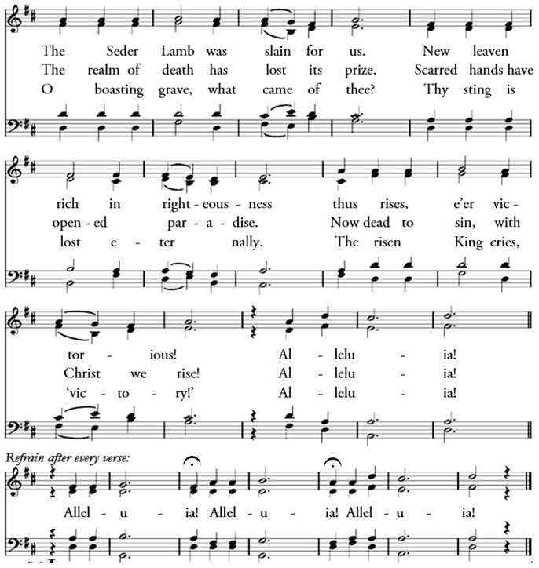

Minister. The Lord be with you.
People. And with your spirit.
Minister Let us pray.

The Collect for the Great Vigil of Easter

O
GOD, you made this most holy night to shine with the glory of the Lord’s resurrection: Stir up in your Church that Spirit of adoption which is given to us in Baptism, that we, being renewed both in body and mind, may worship you in sincerity and truth; through Jesus Christ our Lord, who lives and reigns with you, in the unity of the Holy Spirit, one God, now and for ever. Amen.
The Epistle Lesson: Romans 6:3-11 (ESV)
Reader. A reading from Paul’s epistle to the church in Rome.
D

o you not know that all of us who have been baptized into Christ Jesus were baptized into his death? ⁴ We were buried therefore with him by baptism into death, in order that, just as Christ was raised from the dead by the glory of the Father, we too might walk in newness of life. ⁵ For if we have been united with him in a death like his, we shall certainly be united with him in a resurrection like his. ⁶ We know that our old self was crucified with him in order that the body of sin might be brought to nothing, so that we would no longer be enslaved to sin. ⁷ For one who has died has been set free from sin. ⁸ Now if we have died with Christ, we believe that we will also live with him. ⁹ We know that Christ, being raised from the dead, will never die again; death no longer has dominion over him. ¹⁰ For the death he died he died to sin, once for all, but the life he lives he lives to God. ¹¹ So you also must consider yourselves dead to sin and alive to God in Christ Jesus.

Reader. The Word of the Lord.
People. Thanks be to God.

Sequence Hymn: The Christ Who Died But Rose Again
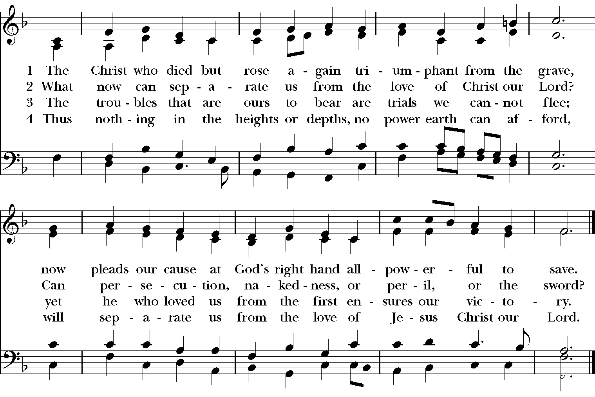
Verses 1-2 are sung before the reading of the Gospel, 3-4 after it.

The Gospel Lesson: Matthew 28:1-10 (ESV)
Reader. The Holy Gospel of our Lord Jesus Christ according to Matthew.
Answer. Glory to you, Lord Christ.
+

Now after the Sabbath, toward the dawn of the first day of the week, Mary Magdalene and the other Mary went to see the tomb. ² And behold, there was a great earthquake, for an angel of the Lord descended from heaven and came and rolled back the stone and sat on it. ³ His appearance was like lightning, and his clothing white as snow.⁴ And for fear of him the guards trembled and became like dead men. ⁵ But the angel said to the women, “Do not be afraid, for I know that you seek Jesus who was crucified. ⁶ He is not here, for he has risen, as he said. Come, see the place where he lay. ⁷ Then go quickly and tell his disciples that he has risen from the dead, and behold, he is going before you to Galilee; there you will see him. See, I have told you.” ⁸ So they departed quickly from the tomb with fear and great joy, and ran to tell his disciples. ⁹ And behold, Jesus
met them and said, “Greetings!”
And they came up and took hold of his feet and worshiped him. ¹⁰ Then Jesus said to them, “Do not be afraid; go and tell my brothers to go to Galilee, and there they will see me.”

Reader. The Gospel of the Lord.
Answer. Praise to you, Lord Christ.

The Homily The Rev’d Chad Lawrence

The Prayers
Father, we pray for your holy Catholic Church;
That we all may be one in Christ.

Grant that every member of the Church may truly and humbly serve you;
That your Name may be glorified by all people.

We pray for all bishops, priests, and deacons;
That they may be faithful ministers of your Word and Sacraments.

We pray for all who govern and hold authority in the nations of the world;
That there may be justice and peace on the earth.

Give us grace to do your will in all that we undertake;
That our works may find favor in your sight.

Have compassion on those who suffer from any grief or trouble;
That they may be delivered from their distress.

We praise you for your saints who have entered into joy;
May we also come to share in your heavenly kingdom.

Let us commend ourselves, and one another, and all our life to Christ our God. For yours is the majesty, O Father, Son, and Holy Spirit; yours is the kingdom and the power and the glory, now and forever. Amen.

L
Invitation to Confession
ET US confess our sins against God and our neighbor.

General Confession, said by all.
M
OST merciful God, we confess that we have sinned against you in thought, word, and deed, by what we have done, and by what we have left undone. We have not loved you with our whole heart; we have not loved our neighbors as ourselves. We are truly sorry and we humbly repent. For the sake of your Son Jesus Christ, have mercy on us and forgive us; that we may delight in your will, and walk in your ways, to the glory of your Name. Amen.

Absolution
A
LMIGHTY God, our heavenly Father, who in his great mercy has promised forgiveness of sins to all those who sincerely repent and with true faith turn to him, have mercy upon you, pardon and deliver you from all your sins, confirm and strengthen you in all goodness, and bring you to everlasting life; through Jesus Christ our Lord. Amen.

The Comfortable Words
H
EAR the comfortable words from the Word of God to all who truly turn to him.
Come to me, all who labor and are heavy laden, and I will give you rest.
-MATTHEW 11:28

God so loved the world, that he gave his only-begotten Son, that whoever believes in him should not perish but have eternal life. -JOHN 3:16

The saying is trustworthy and deserving of full acceptance, that Christ Jesus came into the world to save sinners. -1 TIMOTHY 1:15

If anyone sins, we have an advocate with the Father, Jesus Christ the righteous. He is the propitiation for our sins, and not for ours only, but also for the sins of the whole world. -1 JOHN 2:1-2

Minister. The Peace of the Lord be always with you.
People. And with your spirit.

Offertory Sentence. You are a chosen race, a royal priesthood, a holy nation, a people for his own possession, that you may proclaim the excellencies of him who called you out of darkness into his marvelous light. I Peter 2:9.

Doxology (tune: lasst uns erfreuen)
The Sacrament of Holy Communion (the 1662 Order)

Minister. The Lord be with you.
Answer. And with your spirit.
Minister. Lift up your hearts.
Answer. We lift them up to the Lord.
Minister. Let us give thanks to the Lord our God.
Answer. It is right to give Him thanks and praise.

I
T is right, our duty and our joy, always and everywhere to give thanks to you, Father Almighty, Creator of heaven and earth;

B

UT chiefly are we bound to praise you for the glorious Resurrection of your Son Jesus Christ our Lord: for he is the true Paschal Lamb, which was offered for us, and has taken away the sin of the world; who by his death has destroyed death, and by his rising to life has restored to us everlasting life.

T
HEREFORE we praise you, joining our voices with Angels and Archangels and with all the company of heaven, who for ever sing this hymn to proclaim the glory of your Name:
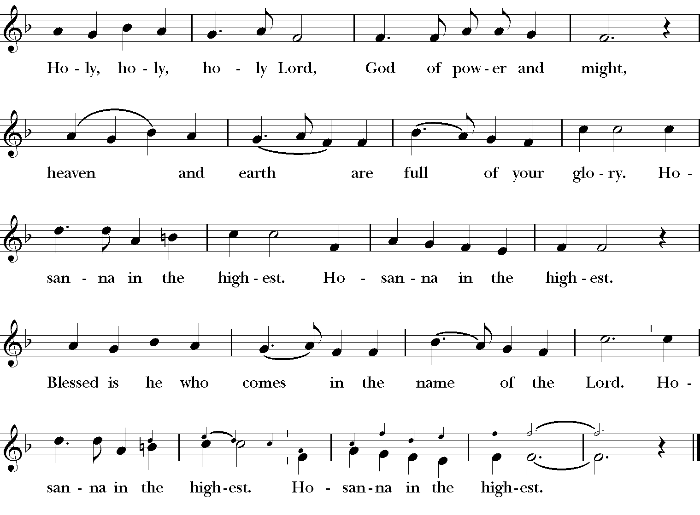

W
The Prayer of Humble Access, said by all, kneeling.
E do not presume to come to this your table, O merciful Lord, trusting in our own righteousness, but in your abundant and great mercies. We are not worthy so much as to gather up the crumbs under your table; but you are the same Lord whose character is always to have mercy. Grant us, therefore, gracious Lord, so to eat the flesh of your dear Son Jesus Christ, and to drink his blood, that our sinful bodies may be made clean by his body, and our souls washed through his most precious blood, and that we may evermore dwell in him, and he in us. Amen.

The People continue to kneel. The minister stands and continues.
A
LL praise and glory is yours, O God our heavenly Father, for in your tender mercy, you gave your only Son Jesus Christ to suffer death upon the Cross for our redemption. He made there, by his one oblation of himself once offered, a full, perfect, and sufficient sacrifice, oblation, and satisfaction, for the sins of the whole world; and he instituted, and in his Holy Gospel commanded us to continue, a perpetual memory of his precious death and sacrifice, until his coming again. Hear us, merciful Father, and grant that we receiving these gifts from your creation, this bread and this wine, according to your Son our Savior Jesus Christ’s institution, in remembrance of his death and passion, may be partakers of his most blessed Body and Blood; For on the night that he was betrayed, our Lord Jesus Christ took bread; and when he had given thanks, he broke it, and gave it to his disciples, saying, “Take, eat; this is my Body, which is given for you: Do this in remembrance of me.” Likewise, after supper, Jesus took the cup, and when he had given thanks, he gave it to them, saying, “Drink this, all of you; for this is my Blood of the New Covenant, which is shed for you, and for many, for the forgiveness of sins: Whenever you drink it, do this in remembrance of me.” AMEN.

Invitation to Communion. All baptized, believing Christians of an understanding age who are admitted to the Sacrament within their own church are encouraged to receive it with us. The New Testament requires some understanding of the Supper, instructing those who commune to ‘discern’ the Body as well as ‘examine themselves’ (I Cor. 11) before partaking. It is the historic and consistent Anglican practice for young children to be catechized before receiving the Supper (please contact a minister for catechism resources). Please walk down the middle aisle to receive the bread in open hands and then consume it. Drinking the wine directly from the common cup is the customary manner of receiving it, though the bread may be carefully intincted (dipped) into the wine. Small, individual cups of wine are available in the front for those who have health concerns.
Intercessory prayer is available in the back of the church. This takes place during the distribution of Communion. You can come back for prayer for any reason whatsoever. If you want prayer for healing (physical or otherwise), you can also request anointing with oil (a biblical symbol for healing and restoration).

See, the Easter Lilies Bloom! Words: Tompkins, 1897 Tune: Dix

1. Flee away, ye shades of night!
Sweetly breaks the morning light;
Never was there morn like this,
Dawning of eternal bliss;
As the light dispels the gloom,
See, the Easter lilies bloom!

2. Flee away, O dark despair,
As I greet the morning fair;
Like the Master I shall rise,
Where the daylight never dies;
At the portal of the tomb,
See, the Easter lilies bloom!
3. Risen Lord and Savior dear,
Let me feel Thee ever near.
From Thine empty tomb there beams
Risen hopes o’er faded dreams;
E’en amidst the valley’s gloom,
See, the Easter lilies bloom!

4. As the crocuses of gold,
Rest within the lilies’ fold,
Sweetly I may rest in Thee
And o’er death cry Victory!
Boasting grave, I read thy doom,
In the Easter lilies’ bloom!

O Praise the Name
1. I cast my mind to Calvary where Jesus bled and died for me
I see His wounds, His hands, His feet my Saviour on that cursed tree
2. His body bound and drenched in tears they laid Him down in Joseph's tomb
The entrance sealed by heavy stone messiah still and all alone

Chorus: O praise the name of the Lord our God - O praise His name forevermore
For endless days we will sing Your praise - O Lord, O Lord our God
3. And then on the third at break of dawn the Son of heaven rose again
O trampled death where is your sting? The angels roar for Christ the King (Chorus)
4. He shall return in robes of white the blazing sun shall pierce the night
And I will rise among the saints my gaze transfixed on Jesus' face (Chorus)

O
And now, as our Savior Christ has taught us, we are bold to pray,
UR Father, Who art in heaven, hallowed be thy Name, thy kingdom come, thy will be done, on earth as it is in heaven. Give us this day our daily bread. And forgive us our trespasses, as we forgive those who trespass against us. And lead us not into temptation, but deliver us from evil. For Thine is the kingdom, and the power, and the glory, forever and ever. Amen.

A
Post-Communion Prayer, said by all
LMIGHTY God, we thank you for feeding us with the spiritual food
of the body and blood of your Son Jesus Christ. Through him we offer you our souls and bodies to be a living sacrifice. Send us out into the world
in the power of your Spirit, to live and work to your praise and glory. Amen.

The Easter Blessing
T
HE God of peace, who brought again from the dead our Lord Jesus, that great shepherd of the sheep, through the blood of the eternal covenant, make you perfect in every good work to do his will, working in you that which is well-pleasing in his sight; and the blessing of God almighty, the Father, the Son, and the Holy Spirit, be among you and remain with you always. Amen.

Recessional Hymn: Christ our Hope in Life and Death

1. What is our hope in life and death? Christ alone, Christ alone
What is our only confidence? That our souls to him belong
Who holds our days within his hand? What comes, apart from his command?
And what will keep us to the end? The love of Christ, in which we stand

Chorus: O sing Alleluia! Our hope springs eternal;
O sing Alleluia! Now and ever we confess
Christ our hope in life and death

2. What truth can calm the troubled soul? God is good, God is good
Where is his grace and goodness known? In our great Redeemer's blood
Who holds our faith when fears arise? Who stands above the stormy trial?
Who sends the waves that bring us nigh Unto the shore, the rock of Christ? (Chorus)

3. Unto the grave, what will we sing? "Christ, he lives; Christ, he lives!"
And what reward will heaven bring? Everlasting life with him
And we will rise to meet the Lord then sin and death will be destroyed
And we will feast in endless joy when Christ is ours forevermore (Chorus)

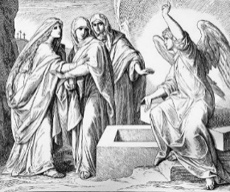

Alleluia, Alleluia! Let us go forth in the name of Christ.
Thanks be to God. Alleluia, Alleluia!

LET US RING THE BELLS
by Aaron Cowan

Let us ring the bells today
Not the tinny, half-hearted bells
in gloved Salvation Army hands
seeking coins from hurried shoppers
Nor the sterile push-button bells,
in laboratories bereft of joy,
that summoned Pavlov’s dogs to drool
Nor yet the somber funeral bells
echoing through old English stone
stirring Donne to mournful thought
No, let us ring better bells today
Let us ring the bells that awaken Ebeneezer Scrooge,
gleeful because he hasn’t missed it—
Christmas Day is here
and the prize turkey as big as a boy
can still be sent ‘round to Bob Cratchit

Let us ring the bells that herald bride and groom
Bursting forth from the chapel door
Love-drunk and radiant;
The honeymoon has begun, and laundry and bills
and troublesome in-laws banished forever
Let us ring the bells that clatter – finally!
at 3:00 pm on school’s last day
sweeping away homework and tedious textbooks
As the Kool-Aid man bursts through the classroom wall
christening an endless summer
Yes, let us ring these bells this Easter day
bells of frolic and redeeming love,
of the old deep magic come true
Bringing early June, now and for always

Let us ring these bells unceasingly, boldly;
(like terrible angels, or the delirious, sugar-fueled children we really are)
until at last — loosed from their strings by our reckless clamor —
they launch into space, still resonant with the bright joy of resurrection

